Project Team: Supply Ordering Process – DHE – Johnson County
Timeline: Feb 3, 5-7, 2014

SOLVE
What is the Approach?
9. Team Members & Roles
10. Project Schedule
11a. Data and Information Collection
What are your Conclusions?
13. Improvement Hypotheses & Problem Solving Summary
What is the Gap?
1. Starting Point
2. Vision
3. Current State
What is the Goal for Improvement?
4. Goal or Target Condition
5. Customers & Beneficiaries
6. Benefit
7. Measures & Targets
8. Conditions

SOLVE
TRY, LEARN, INSTALL
Try Solutions; what did you learn?
14. Construct & Execute tests
15. Document Results
16. Analyze Results & Extract Learning
How will you make the new way happen?
- Plan Rollout & Execute
- Measures of Success
Understanding the Problems:
11b. Current and Future State Process Maps
12. Cause and Effect Diagram

_ SOLVE _
1. Starting Point
- What is the need (e.g. outcome) or gap that caused this project to be considered in the first place?
Data considered in identifying the importance of this QI project include the frequency in which individual orders require clarity prior to completing the process. Clarity is defined as being clear, concise, specific communication as interpreted by the accounting staff. There are numerous methods to place an order with different information fields to complete. Examples of order methods include 4 separate program specific Excel spreadsheets, electronic fillable PDF forms, general email requests for items, a ½ page triplicate supply ordering form that was last revised in 1991, verbal order requests by individuals that present in person, orders that present with purchasing card transactions and a single sheet miscellaneous receipt form.

The extensive time spent on managing the organizations’ orders was another factor included in the importance to study this administrative process. Some orders require researching an exact item, locating best price, finding a vendor, and determining delivery times. Orders may require approval from a supervisor which may or may not be included with the order when it is placed. Finally the accounting staff is responsible to assure there is a specified funding source and that the source has adequate funds to cover the cost. It was determined that the accounting staff spend anywhere from 48 to 63 hours per month processing orders.

The desired outcome of this QI project is to identify a streamlined process for ordering supplies that will decrease the process cycle time. A decrease of cycle time for individual orders from identification of need to item received and P-card reconciled by 60% is the goal.

- Who is establishing the need?
Accounting Staff

c. How is the need being measured and is it possible for this project to make an impact on that measure?
The need is measured by collecting the number of orders within a time period, conducting time studies for each of the steps as well as collecting the number of incidences in which the correct items are received for each order . Accounting staff are tracking orders starting with the receipt of the order from JCDHE staff to the placement of the order with the vendor. This project will make an impact by increasing efficiency and increasing clarity of orders thereby reducing the amount of time to complete an order.

d. What data or analysis was used to establish that this project will make a key impact?
Level of frustration of accounting staff
Information collected for baseline measurement

e. What scope (e.g. geographic, organization, customer) are you expected to impact?
All non-clinic supply orders.

f. What conditions are being placed on this project?
- Stay with TFM policies
- Accounting staff must use Oracle.
- Programs and staff receive supplies needed to continue services without delay

2. Vision (What do you want to achieve in the long range and without any restrictions? Generate a picture or description of your ideal condition. How will it look for the customers, our team, and for the taxpayers/funding sources?)
- What do we want this process to be in 3-5 years? ??

In 3-5 years, we would like to have an efficient, streamlined process for placing orders that has minimal room for error. Ramification

3. Current State (Description of how the process and organization is operating now; Quantitative if possible, always factual and based on observation)
Stakeholder | Description | How do you know?  (Data if available)
Customers | - Internal customers submit orders in various ways | Assessment of current process
Financial | - Excess use of staff time | Staff report  Time studies
Your Team | - Frustration with the current system  - Inefficient use of staff time  - Number of different forms to process  - Inconsistency in the system across divisions and working with all staff | Staff report  Time studies  Assessment of tools used to process orders

4. Goal or Target Condition (What is the objective? Which piece of the gap are you addressing?)
TO: Reduce the staff time spent and steps taken to process supply orders.

5. Customers and Beneficiaries (Who benefits from achieving the goal? What populations are targeted?)
- People receiving services through the JCDHE programs
- Program managers and staff
- Accounting staff

6. Benefit (What are the benefits from achieving the goal?)
SO THAT:
- Staff has more time for other responsibilities
- Communication is clear to all staff involved of what is needed, when it is needed, available budget and from which vendor
- The process is consistent across the department

7. Measures and Targets (What quantitatively will be achieved?)
Beneficiaries | What Measured | How Measured | Target
 |  |  | How Much | By When | Actual
 | Process Cycle Time | Time from identification of need to item received and P-card reconciled | 60% reduction  From ~73 min/order to ~29 min/order | End of March
 | Order Accuracy | Errors between program order and packing lists | From XX% to >90% | End of March

8. Conditions (What do you need to be successful?)
- Business needs to continue
- Orders placed into Oracle system

9. Team Members and Roles (Who is directly involved and How? Training Needs?)
Name | Role | Work process related interests / concerns | Project Expectations | Project, QI skills
Joel Johnson | Accounting Staff | Receives and processes orders
Shelia Terry | Accounting Staff | Receives and processes orders
Lorraine McGinnes | Accounting Staff | Receives and processes orders
Heather Petit | FHS Program Aide
Julie Beach | Immunizations Program Manager
Veronica Sutton | Environmental Customer Service Specialist
Laura Drake | WIC Program Manager
Deb Whiteman | QI Leader |  |  | Kaizen facilitator
Training Needs:

10. Project Schedule (Activities to go about solving the problem)
- By: What is the approach to the problem?
- High level activities:
  - Prepare for event
  - Perform kaizen event
  - Institutionalize event improvements

11a. Data and Information Collection (What will you collect? Who? When?)
WHAT | WHO | WHEN
Order processing & clarification times | Accounting Team | 2 weeks (Jan)

11b. Observe and Document Current Process (Generate a Process Map)

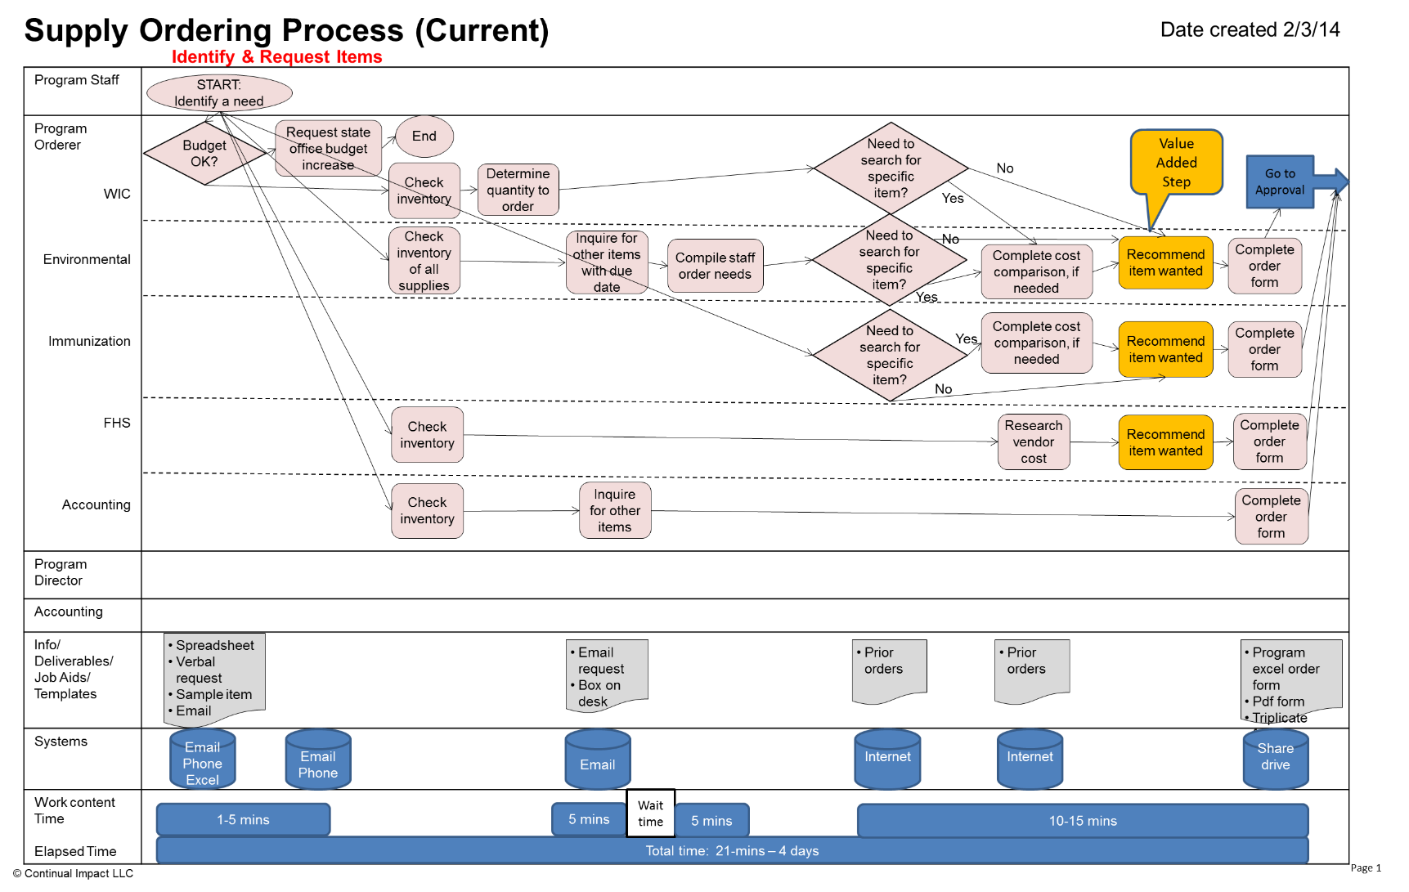
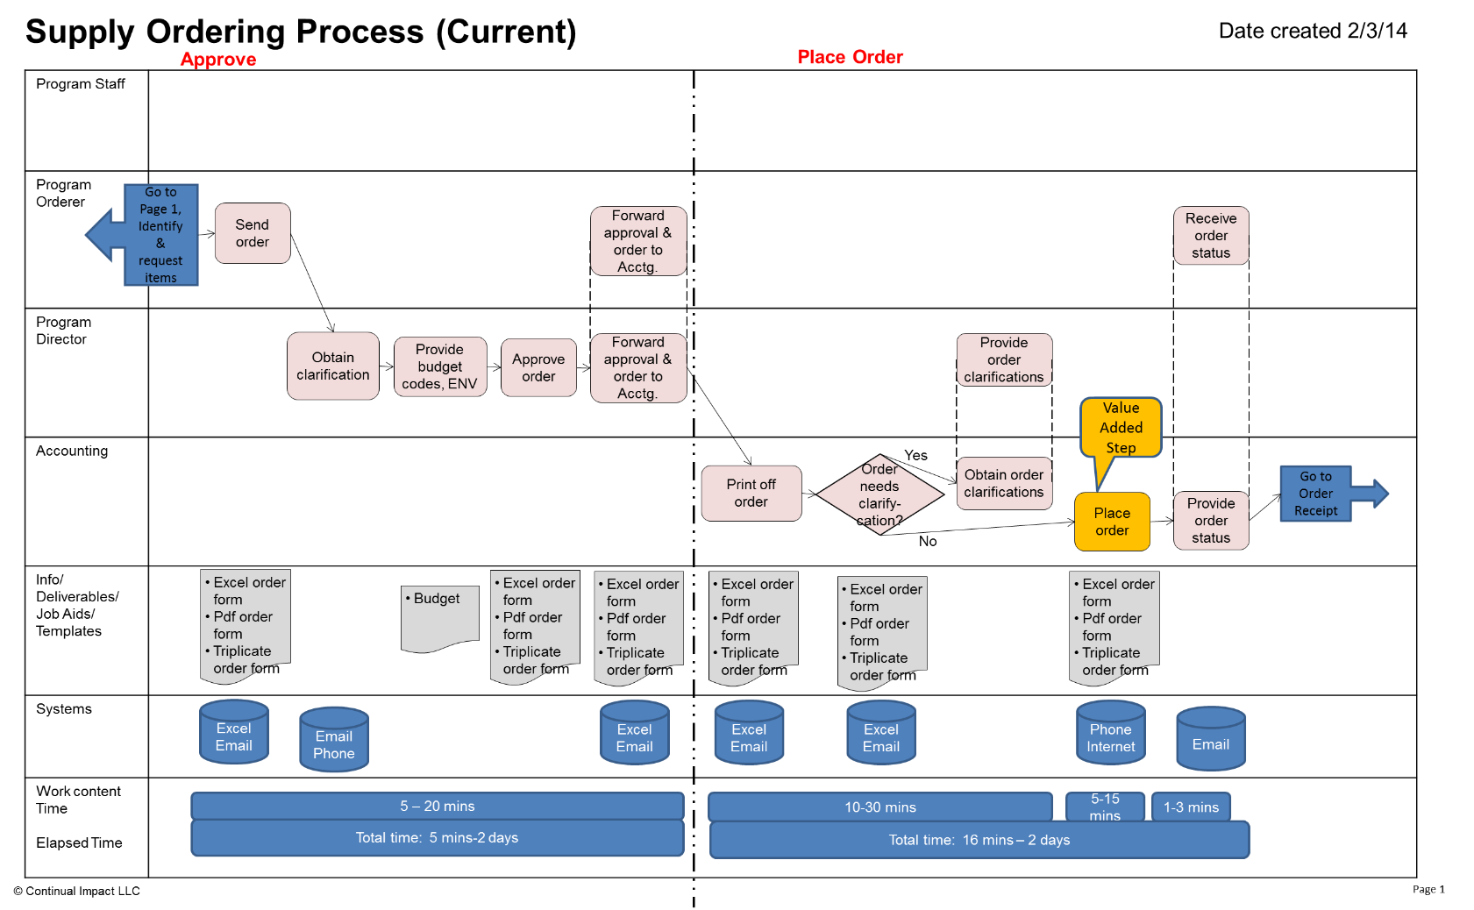
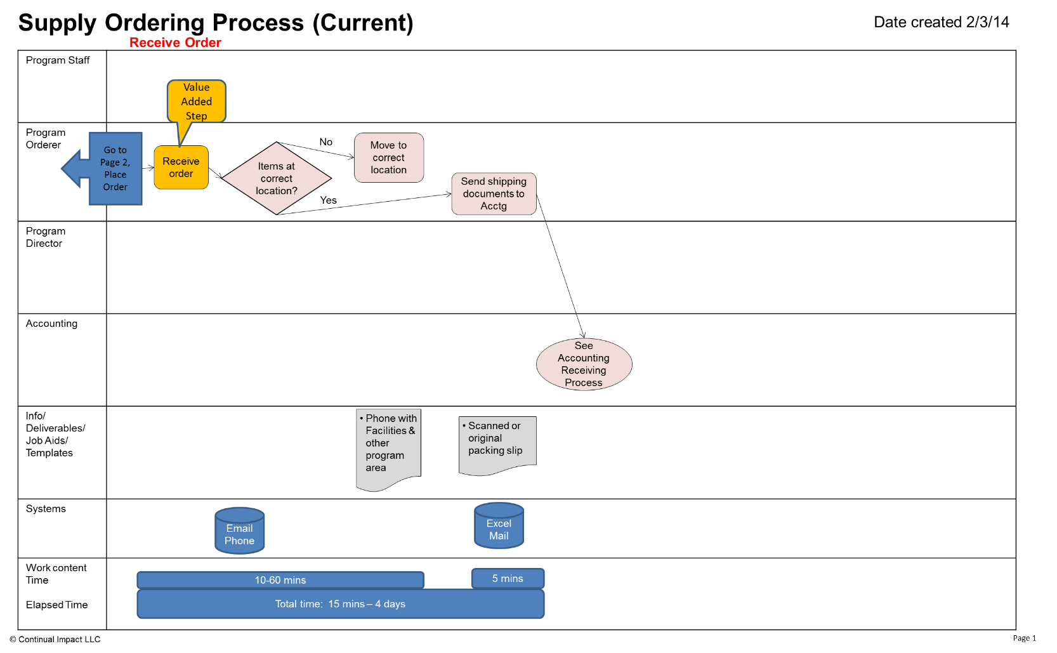

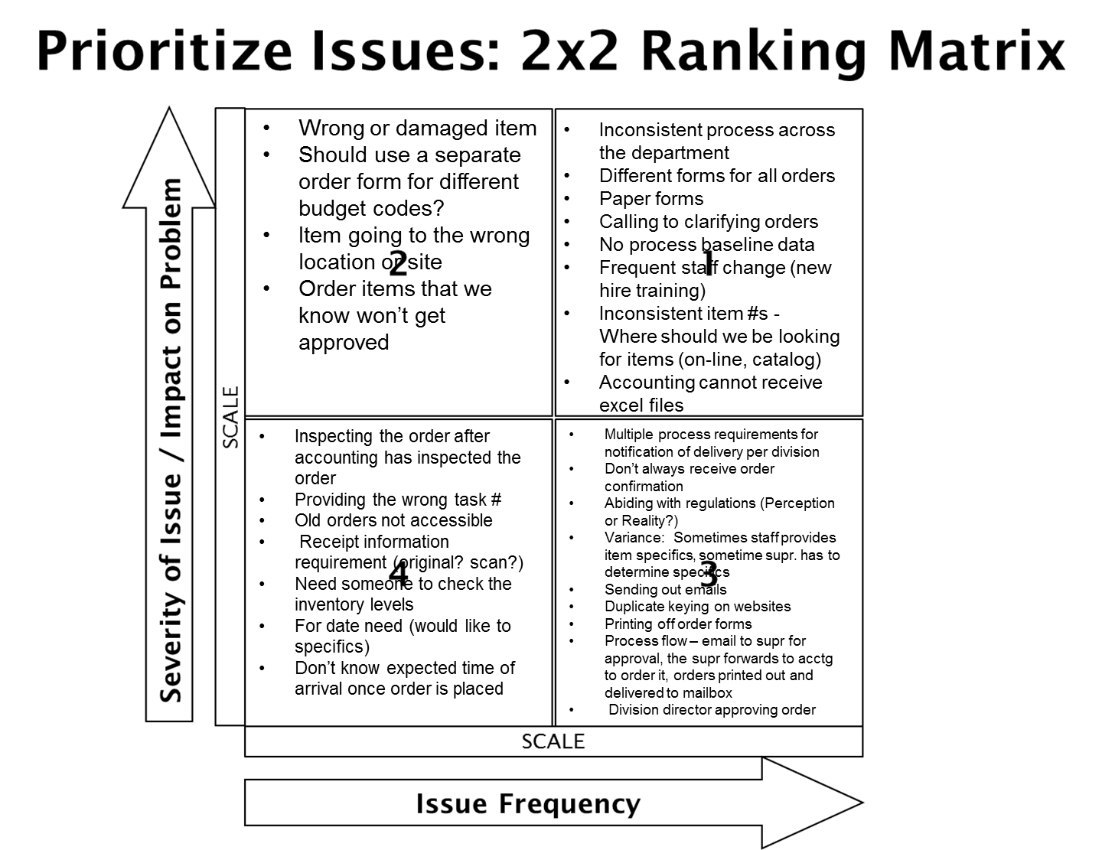

12. Conduct Cause and Effect Analysis (Priority issues and solutions from Cause and Effect Analysis)
Category | Issues/Wastes | Root Causes | Solutions or Additional CI Methods to use | Speed & Cost to Implement
Priority 1 & 2 | Not clear who provides the item specifics | Why 1: Program staff unsure where to look  Why 2: Unsure where it was purchased in the past  Why 3: Did not order previously  Why 4: Not privy to where it was purchased  Why 5: No location to find info.  Why 5: No protocol  Why 5: Different answers | - Reverse the ordering process so that orderer places the order, acctg pays  - Standard vendor list by category (what, vendor, expected price)  - List of items that cannot be ordered  - Distribute p-cards to heavy users  - Shred non-preferred vendor catalog  - Provide Budget visibility to Orderers (use the budget mtg to approve) | See future state process map & 2X2
Priority 2 | Wrong address assigned by Acctg. | Why 1: Drop down box changed  Why 2: Because all items need to be delivered to HSB  Why 3: It’s always been done that way  Why 4: Control  Why 4: Acctg. procedures not documented  Why 2: Not marked correctly on the Supply & Equipment order form  Why 4: It’s always been done that way  Why 2: Human error  Why 3: Not completely marked | - Order by site, not program  - Update order form to include location  - Create 1 standard order form  - Location cannot be DHE, must be DHE-location.
 | Not everyone knows budget codes | Why 1: Historical authorization | - Order form (1 per location) that is a std list where program adds throughout the month (on share point), at 1 point in time place order  - Provide all orderers the list of budget codes
 | Duplicate keying on websites | Why 1: To clarify which item is wanted  Why 1: Going to web to get price  Why 1: Research specific item  Why 1: Order form asks for this info | - Vendor web site – has a portal for orderer to submit order then Acctg. Can go in and pay.

Complete orders include:
- Contact name/number
- Date needed
- Location needed (drop down menu with HHW)
- Vendor
- Cost center – budget codes (county funds)
- Budget
- Price / cost
- Item
- Quantity
- Items #s
- Time needed (food)
- Quotes (per policy)
- Small description
- Task # / category (grant codes)
- Check pricing for parameters & quotes per policy – above purchasing threshold
- Proper approval – threshold/program policy
- Accurate order (Y/N)

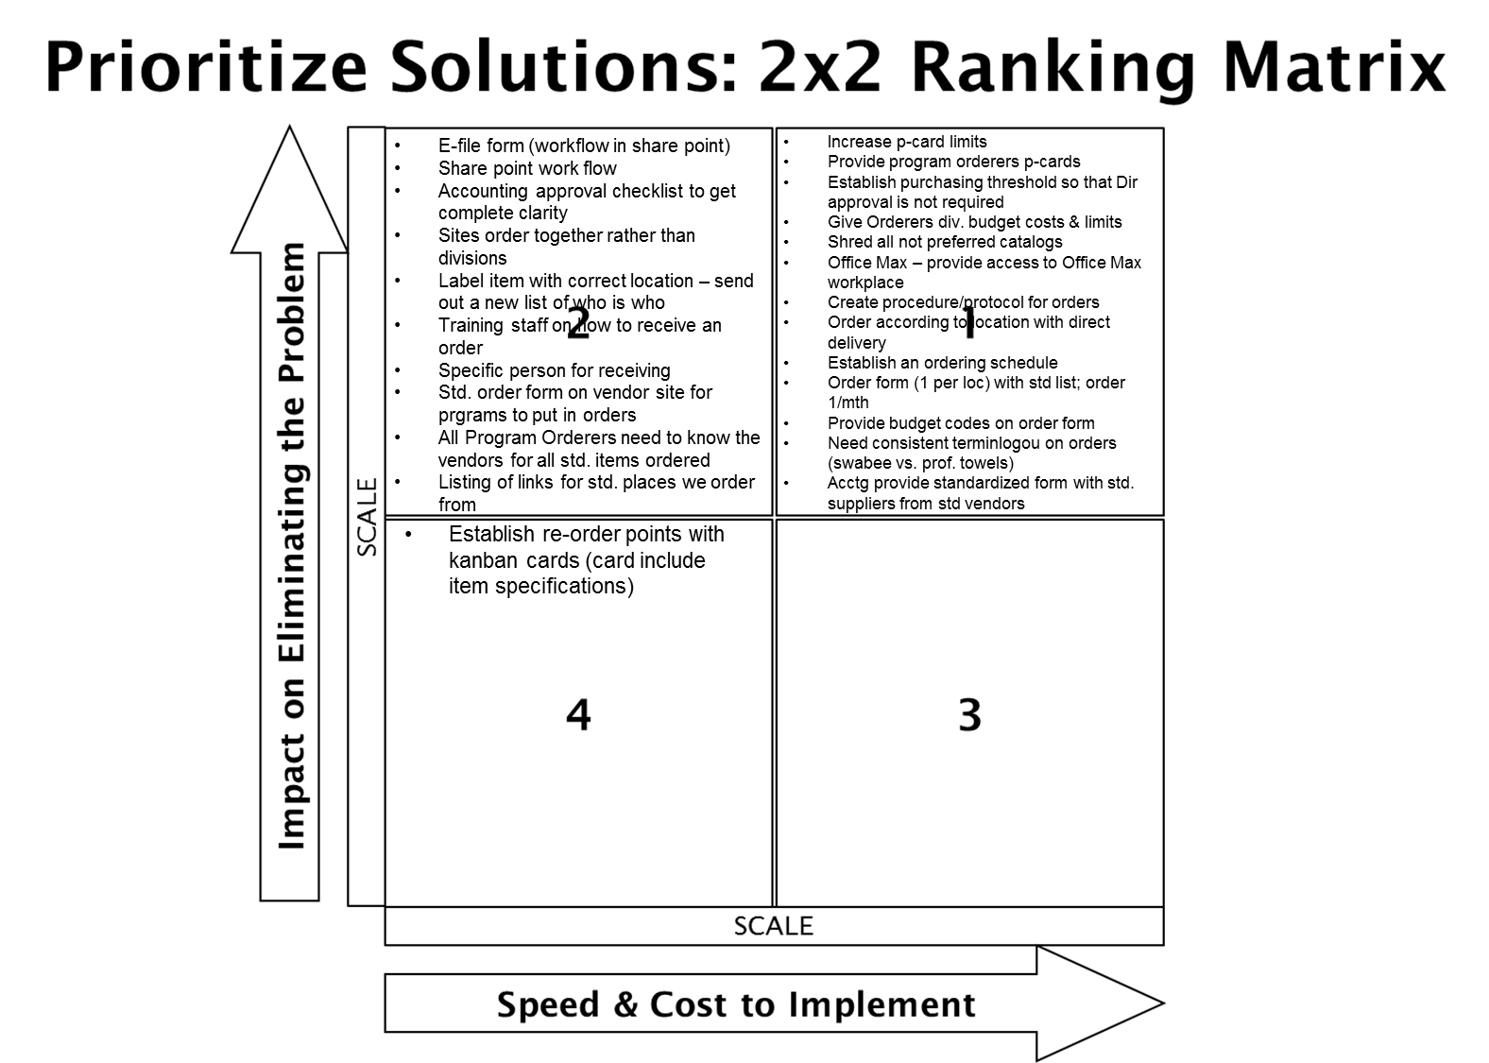

Decisions:
- Program Orderers have
  - P-cards with thresholds of $1000 / mth
  - The authority to place orders
  - Access to budget codes
- List of standard items (vendor, cost)
- Order form on share point – all inclusive of complete items orders

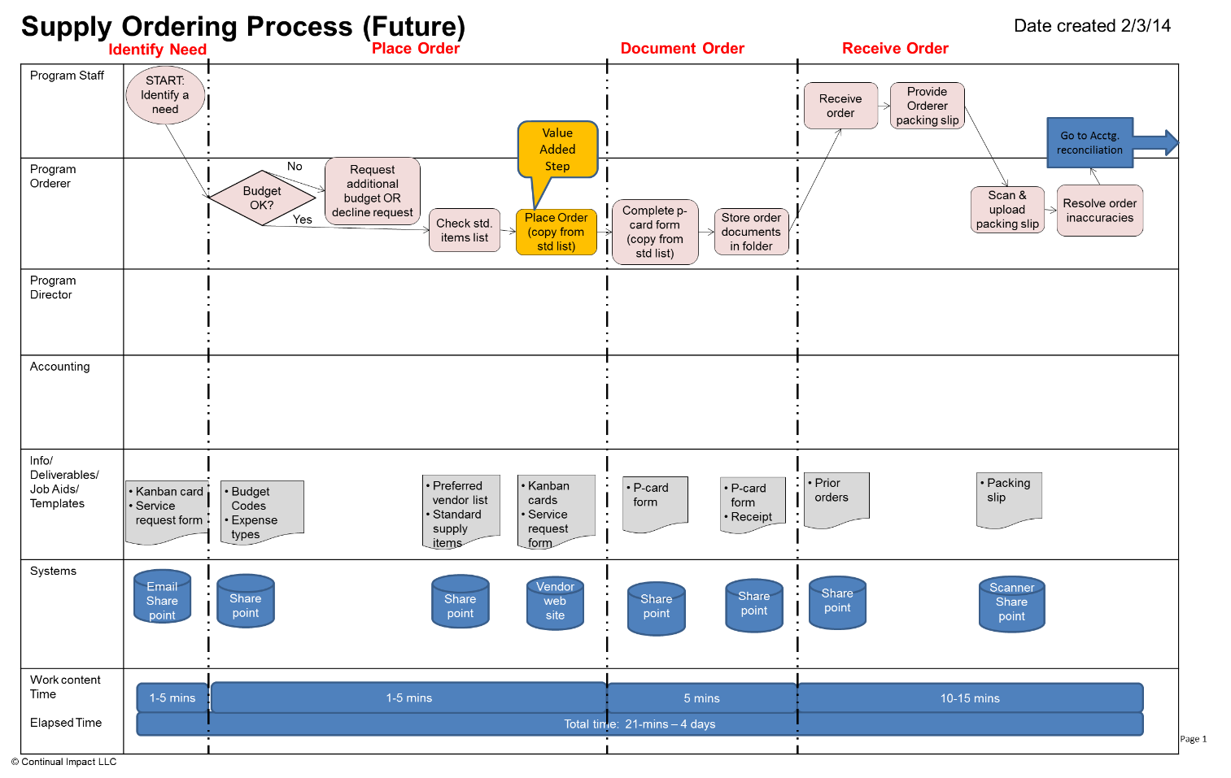
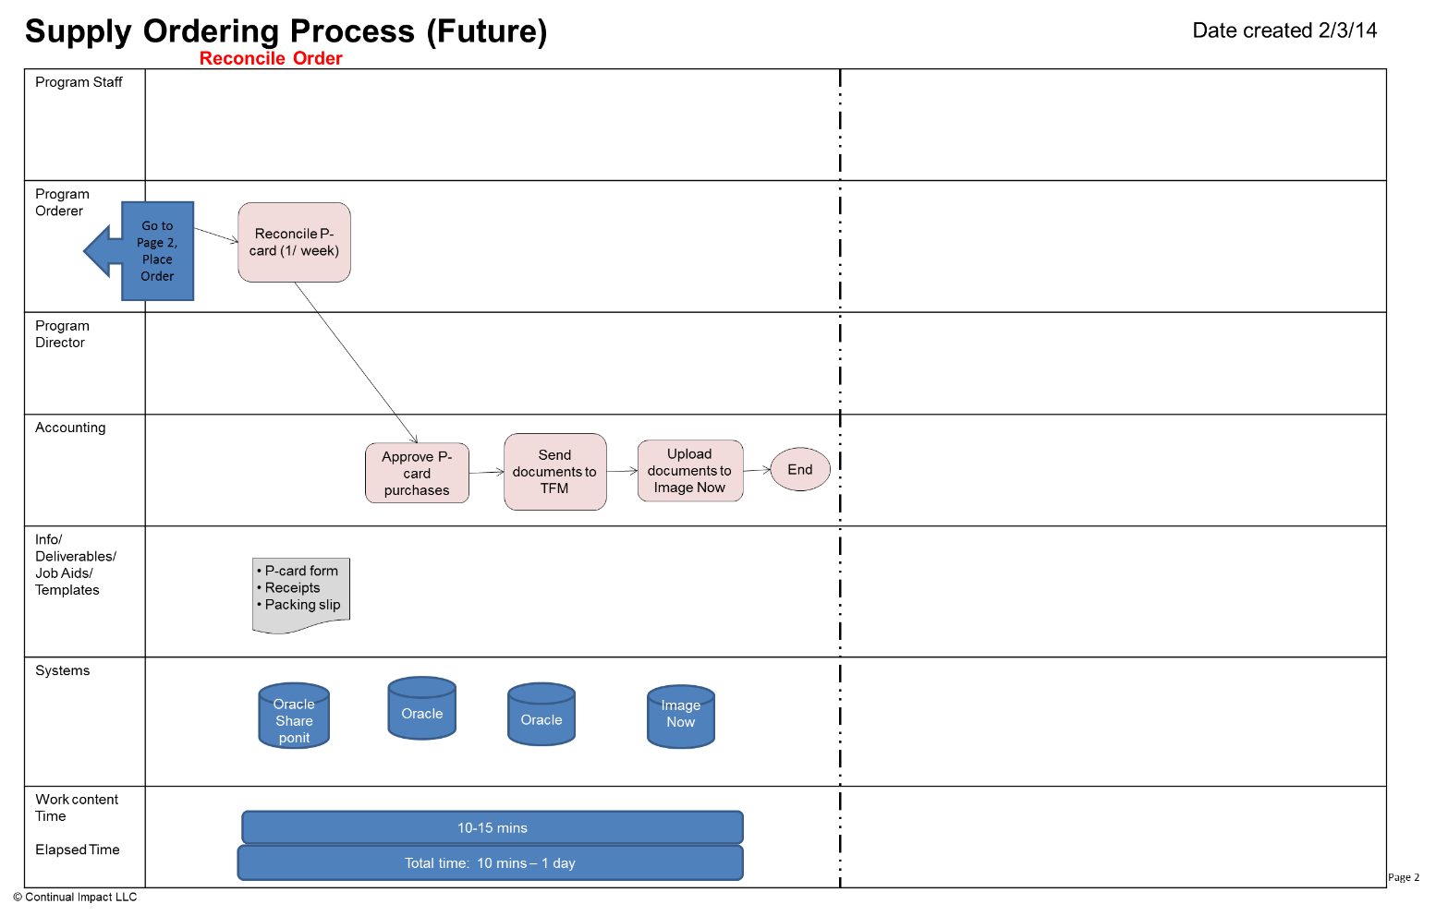

13. Improvement Hypothesis (Summary of potential means to achieve goal)
Issue | Improvement | Expected Results
Consistent work process | If we redesign the process to eliminate wastes and redundancies provide job aids to help identify needed and correct information, decision making guidelines… | … then defects and clarification time will be reduced and overall labor time required (employee time) to complete the process will be reduced
Duplicate keying | If we provide the Program Orderer all the knowledge and authorization (p-cards, std forms, and std items list… | The order can be placed on first touch
Accuracy | If we consolidate to 1 order form that provides all the order elements… | … then we will gain consistency and accuracy

_ TRY _
14. Test Hypotheses (How will you test the potential solutions?)
Tests | How | When | Who | Successful if…
P-card form | Cindy |  |  | P-card is simple so that it does not take lots of time for Program Orderer
Std. items list |  |  |  | Program Orderer can use this,
End to End Process (with Kanban card, service request form) | Laura, Veronica | Thursday AM | Laura & Veronica with Mary & Phyllis | They understand where to look on SharePoint to complete service request form  Can complete the form, order, print screen, save order  Can create folder & upload to SharePoint  Identify things to make this easier/smoother

15. Results: attach graph/table of actual trial performance

Purchase request completion 2 minutes 30 seconds.

Mary checking budget, looking at standardized list, placed order 8 min 59 seconds. Successful. Had questions along the way.

Email will go to staff member ordering. Built the folder. Screen shot of the two items needed 2 min 56 sec. filled out p-card transaction form 3 min 40 sec. questions, what is file number? Change to folder name instead of file number.

3 min 40 sec. Connie signed receipt, sent email to Mary. 40 sec. Mary uploaded to folder 57 sec. return to P-Card Transaction form to complete receipt. Reporting accuracy.

Total 19 minutes 47 seconds. With lots of coaching & Q/A

_ LEARN _
16. Learning (For the trials, what worked and did not, why and what are you doing as a result? Is the result repeatable?)
Reasons | Learning: Why? | Direction: Actions to be taken
Testing of Purchase Request | Order Items on purchase request, mandatory fields are not accurate. | Change fields to be more user friendly. Drop down for quantity descriptions.
Testing of Purchase Request | Need to be more specific with ordering, does email go to the orderer. Answer was yes. | Status on service request will be changed to complete.
Testing of Purchasing Process | What cost center was? Gave her the info, would be able to access on SharePoint. Confused about what task # was. Print to pdf and send to SharePoint. | Change task (grant or project only) training will solve most of these issues. Justification – may be wrong terminology. Suggest changing to reason for ordering.
Printer in the room | Ability to have printer access locally for development of templates and job aids. | Plan for next event.
Network access present | Participants were able to have full access to files and web based programs for clarification of the current process in addition to having full access to documents. | Plan for next event.
Utilized meeting room on lower level away from daily business activities | This helped with the concept that the team was not available for consultation and decreased disruptions | For future events, I recommend scheduling the room with the same benefit in mind. Off site is not an option as we needed to be close to the gemba for testing.
Scheduled 15 minutes of review for the Executive Team at the end of each day | Created a transparent atmosphere, allowed for questions/concerns to be addressed. | Invite the stakeholders for daily reports of what was accomplished.
Lunches were planned the week prior to the event to allow easy ordering plan for delivery when possible or to assign a person to retrieve the lunches. | Removed these type of decisions from the tight schedule of each day. | Plan for next event.

_ INSTALL _ 17. Installation Plan (Steps to operationalize the new process and make it stick. Attach new process map below.)

What | Who | When
ET Overview | Laura | Feb 12th
Leadership Overview | Joel | Feb 19th
P-card Overview | Julie, Heather | Feb 21st
On-line P-card training for new card holders |  | Feb 28
P-card Training (including Oracle, sharepoint, vendor sites) | Lorraine, Acctg. | Mar 14 week
All Staff Overview | Kaizen team | Mar 28th
Receivers | Laura – Mission, Veronica – ENV, Joel - HSB | Done by week of Mar 14
Go-Live March 31st

18. Measure Success attach graph/table of installed performance

April Audit May Audit
Identifying the Need = 15 sec Identifying the Need =
Placing the Order = 8 min 12 sec Placing the Order =
Documenting the Order = 8 min 10 sec Documenting the Order =
Total Process Time = 16 min 37 sec Total Process Time =

100% Accurate Items Received as Ordered 100% Accurate Items Received as Ordered

