Project Team: Columbus Ohio Public Health; “There’s Got To Be A Better Way!” Getting SNT Vaccination Records Into the NextGen System
Timeline: 13 July 2015 Kaizen Event

SOLVE
What is the Approach?
9. Team Members & Roles
10. Project Schedule
11a. Data and Information Collection
What are your Conclusions?
13. Improvement Hypotheses & Problem Solving Summary
What is the Gap?
1. Starting Point
2. Vision
3. Current State
What is the Goal for Improvement?
4. Goal or Target Condition
5. Customers & Beneficiaries
6. Benefit
7. Measures & Targets
8. Conditions

SOLVE
TRY, LEARN, INSTALL
Try Solutions; what did you learn?
14. Construct & Execute tests
15. Document Results
16. Analyze Results & Extract Learning
How will you make the new way happen?
- Plan Rollout & Execute
- Measures of Success
Understanding the Problems:
11b. Current and Future State Process Maps
12. Cause and Effect Diagram

_ SOLVE _
1. Starting Point
- What is the need (e.g. outcome) or gap that caused this project to be considered in the first place?
Timely and efficient inputting of records into the electronic management system (EMS) is a revenue generating process. If the records are not submitted to the insurance companies without errors and within a set amount of time then the reimbursement is rejected. From October 1 – December 31, 2014, 4578 influenza vaccines were administered by CPH’s Strategic Nursing Team. Data entry staff required more than 85 days (680 hours) to enter the records and submit them to the billing department. These vaccinations occurred during the 2014-15 school year at various Columbus school locations outside the main building of CPH. Immunization data entry process involves a slightly different procedure for entering as it does elsewhere in the health department. Instead of a record being entered at the time of service, the data entry forms are brought back to the health department and given to a temporary staff person or contractor to enter. The data entered by these people impacts not only internal customers (such as billing staff and nursing staff) but more importantly the external customers. The current process is pulling staff from their regular jobs in order to prepare the documents and train the rotating staff of contractors. This year there were 8 different data entry contractors, which is a time consuming process. This pulls staff from being able to process the records for submission to the insurance company for reimbursement. There is a large amount of wasted staff time and resources occurring to accommodate the process as it currently stands.

b. Who is establishing the need?
The staff from both the billing area as well as the Strategic Nursing Team

c. How is the need being measured and is it possible for this project to make an impact on that measure?
- # of children vaccinated or forms counted to measure volume
- # of records entered (including # of demographic records per day, # of administration records per day & total records)
- Amount of staff time involved (Training contractors, preparing work for contractors, answering questions, logistics)
- Amount of time and money paid for data entry staff time
- Lost revenue or error rate
- Duplicate vaccinations due to records lost

d. What data or analysis was used to establish that this project will make a key impact?
    - 49000 students
    - # of data entry forms or vaccinations administered; 4911 flu immunizations, 433 TDAP
    - Timing is Oct-Jan for immunization and Apr-May for TDAP
    - Cycle time is approx. 85 Days (680 working hours).
    - Work content is approx. 1150 hrs for Contractors
    - Demographics programming is approx 50/day. Admin programming is approx. 50/day. Total/day =25.

e. What scope (e.g. geographic, organization, customer) are you expected to impact?
- Start: Process begins with the letter to parents. The Strategic Nursing Team (SNT) administers the vaccination in the school, collects the data entry forms and submits them to the lead RN to double check for completeness/errors. The lead nurse then turns the sheets over to the billing department to prepare for data entry.
- End: The record is submitted to the billing department and is ready for processing for insurance company.

f. What conditions are being placed on this project? (Leadership requirements or boundaries)
- Not allowed to violate civil service or union rules.
- All solutions with associated costs need to abide by city of Columbus rules and to be approved by leadership.
- The solutions must fit within resource or budgetary availability but the project ideas are not to be limited simply on the aspect of cost.
- The project does not include the billing review process and submission to the insurance company.

2. Vision (What do you want to achieve in the long range (i.e. 10 years) and without any restrictions? Generate a picture or description of your ideal condition. How will it look for the customers, our team, and for the taxpayers/funding sources?)
- A fast work process that enables us to help more children receive immunization; Documentation in the EMR system complete and correct the first time without being a hindrance. All areas that utilize the system are paper free.

3. Current State (Description of how the process and organization is operating now; Quantitative if possible, always factual and based on observation)
Stakeholder | Description | How do you know?  (Data if available)
Customers | - Difficulties in filling out forms may make parents less inclined to have their children immunized. If the process of submitting information is clearer and simpler, immunization rate may be improved. | anecdotal
Financial | - There currently is a cost to hire contractors to enter the records (roughly 3 people for 3 months, 4 days/wk).  - There is a cost to train and manage the contractors.  - The amount of money reimbursed from insurance companies may be less than the doses administered | -$12,775 Contractor cost (not including training and management)
Your Team | - Staff spend a large amount of time prepping records for contract staff  - Staff spend a large amount of time training contract staff in NextGen only to have some of the contractors not return the next day – process starts over again.  - If a mistake is made in the entering process, the billing staff need to fix it before submission to insurance company
Society

4. Goal or Target Condition (What is the objective? Which piece of the gap are you addressing?)
TO:
- Decrease the amount of cycle time spent getting records into the NextGen electronic management system (EMS) for submission to the insurance companies for reimbursement by 50%. (Overall process begins with the letter to parents and ends when records are submitted to the billing department to be processed. Portion of overall process targeted for cycle time reduction: Time from completion of vaccinations at a school to electronic record saved into NextGen. Scope of Scope is Influenza and TDAP.)
- Absorb the need for contract labor and associated resources used in the past without adding personnel to CPH.

5. Customers and Beneficiaries (Who benefits from achieving the goal? What populations are targeted?)
FOR:
Parents and children, Billing department, Fiscal department, SNT Nurses, Staff person managing the entering of records.

6. Benefit (What are the benefits from achieving the goal?)
SO THAT:

- Internally:
- Revenues from insurance billing will be received faster.
- Overall cost for executing this process (e.g., contractor time, training and management of contractors, reduced error and rework rate, documentation cost (scanning, fee tickets)), will decrease.
- Patient records would be more quickly accessible to staff (reducing search time; potentially less redundant shots).
- The potential for missed opportunities regarding vaccinations would decrease (with potential for an increase in revenue).
- There is also the opportunity to apply lessons learned to other areas of CPH and further spread the benefits.
- Externally: Vaccination records will be more accurate, electronically documented and universally available to other providers so a) accidental duplication of vaccinations from other providers could decrease, b) the statewide immunization registry would have more accurate records so that all providers could access an updated record more quickly.

7. Measures and Targets (STANDARDS (How will you measure success; Measure and Target? What quantitatively will be achieved?)

Beneficiaries | What Measured | How Measured | Target
 |  |  | How Much | By When | Actual
Health Dept | Contractor Cost | Reduction in amount Dept spends on contracts for contractors (year on year) | - 100% reduction
Health Dept | Work Content Time of Columbus Public Health | Comparison of Current process FTEs to New process FTEs | - Total FTEs internal to CPH unchanged (i.e. absorbs contractor tasks into same # of total FTEs
Health Dept | Cycle Time | Reduction in time from identification of notification/form/letter to immunization record saved in NextGen for billing. | - 50% reduction
SNT & Billing department | Cycle time | Reduction in time from vaccination to when record is saved in NextGen for billing. | - >95%  (% of vaccinations or schools submitted for billing in NextGen within one day)

8. Conditions ((What process or team member requirements or limitations exist? What do you need to be successful?)
- Not allowed to violate civil service or union rules.
- All solutions with associated costs need to abide by city of Columbus rules and to be approved by leadership.
- The solutions must fit within resource or budgetary availability but the project ideas are not to be limited simply on the aspect of cost.

9. Team Members and Roles (Who is directly involved and How? Training Needs?)
Name | Role | Work process related interests / concerns | Project Expectations | Project, QI skills
Melissa Ervin | Process Owner | Clinical Operations – in charge of NextGen for clinics | Solve the issue for how to get external doses administered documented quickly and efficiently | On Quality Team
Laurie Dietsch | QI Leader | Facilitator | Successful Kaizen event | Leads Quality Team and is the one trained for Kaizen
Jane Dickson | SNT Director | Supervises SNT nurses but has hospital experience with Kaizen and EMS | Solve the issue for how to get external doses administered documented quickly and efficiently | On Quality Team and has been on Kaizen team in hospital
Nicole McGarity | IZ | Supervises the IZ program and is new – fresh thinking |  | ???
Licia Reggins | Billing | Errors in records prevent billing, training of contract staff | Free her up to do the work that she is assigned | ???
Sherry Mayes replaced Karen Gentile | SNT Nurse | SNT SME | Solve the issue for how to get external doses administered documented quickly and efficiently | ???
April Jones | Immunizations Data Entry | Involved in data entry process for the IZ clinic. SME |  | ????
Katherine Rybka replaces Caitlin Capper | Ryan White QI person | Wild card – wants to do Kaizen in Ryan White area – thinks outside the box. | Gives them experience at running a Kaizen event in their program | Conducts QI for the Ryan White program. Caitlyn on Quality Team
Jennifer Young | School Liaison | School liaison – would be involved in this process going forward | Determine what her work role is in this process. | ???

Training Needs: Before the session we are going to train the SNT staff how to enter information into NextGen so that they can give input on how to resolve the issues found.

10. Project Schedule (How will you achieve the result? What is the basic approach, activities to go about solving the problem?)
BY:
Kaizen event (Confirm, Prepare, Perform (13-17 July), Institutionalize)
Go Live:

11a. Data and Information Collection (What will you collect? Who? When?)
WHAT | HOW  What is the data source?  What format is the data?  Data separated by categories or groups?  How accurate is the data? (seasonality, variation)  Who collect data from?  How much data needed, by category? How much time is needed to collect?  How will data be collected?  How can the data be analyzed? | WHO | WHEN
What data is needed to know the goal was achieved?
Cycle Time | Amount of time spent in each area (SNT/billing/entering) | SNT/Billing/Contractors
Staff Time | Amount of hours spent on the issue | Billing/Contractors
Volume of records | Amount of doses administered and submitted to billing for processing | SNT
What data is needed to get insight into the problem?
Cycle Time | Amount of time spent in each area (SNT/billing/entering) | SNT/Billing/Contractors
Staff Time | Amount of hours spent on the issue | Billing/Contractors
Volume of records | Amount of doses administered and submitted to billing for processing | SNT
Amount of money spent | Contract for data entry staff contractors to enter data | Billing/Fiscal | $12,775

Defect data
Lost opportunity – not getting from insurance companies

11b. Observe and Document Current Process (Generate a Process Map)
Paste the current state process map and any issue prioritization here.
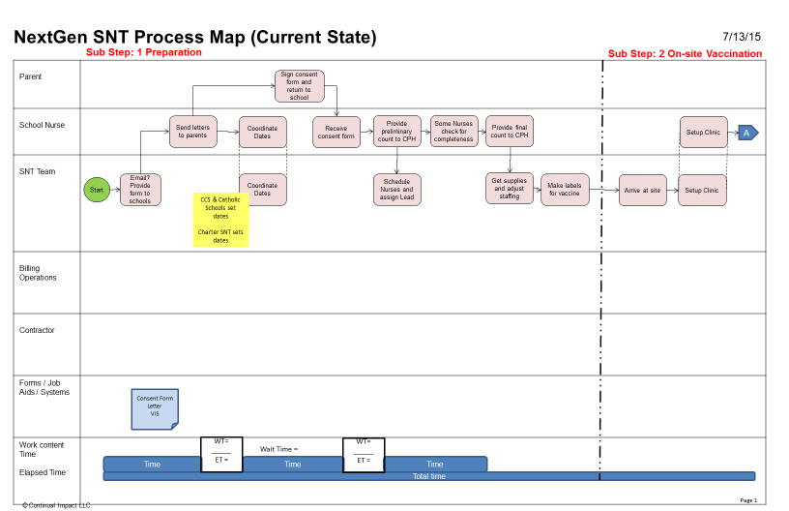

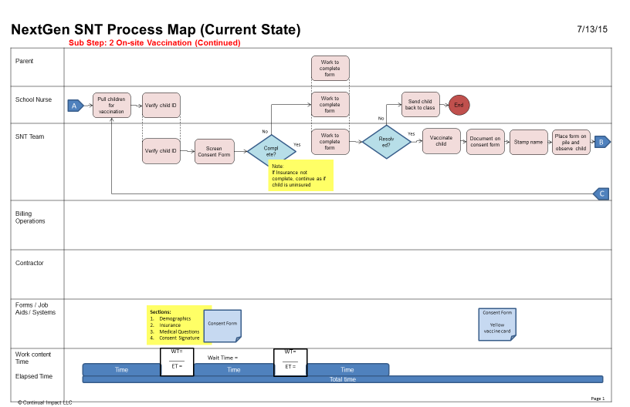
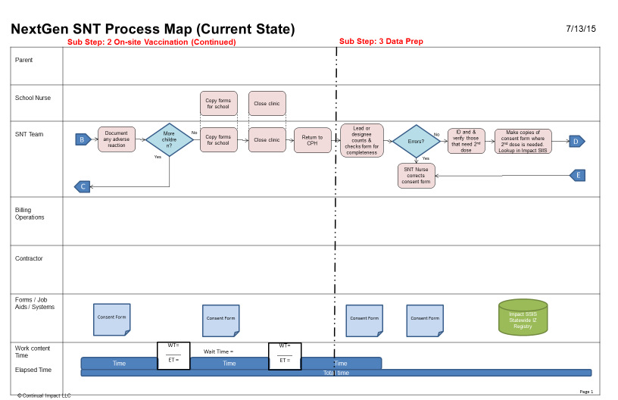
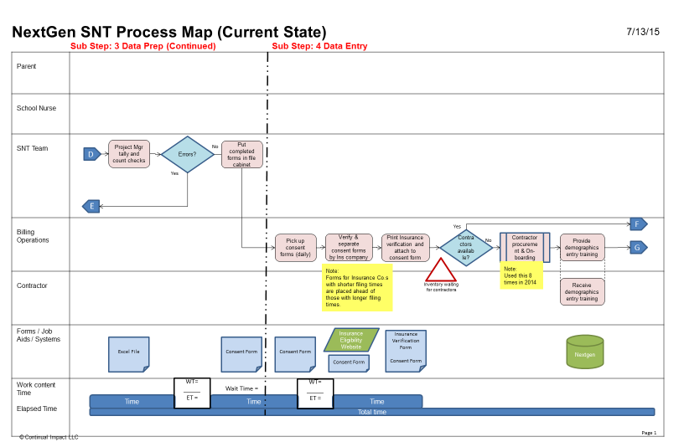
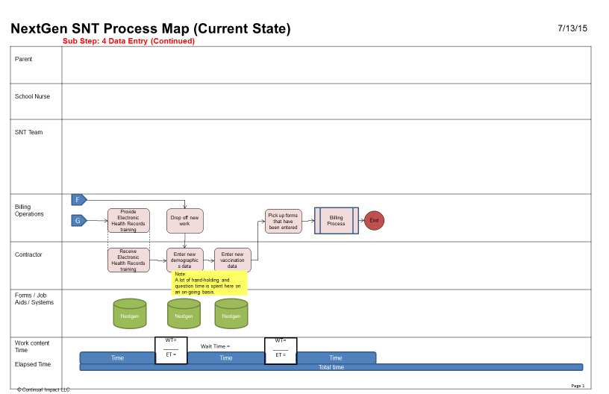

12. Conduct Cause and Effect Analysis (Priority issues and solutions from Cause and Effect Analysis)
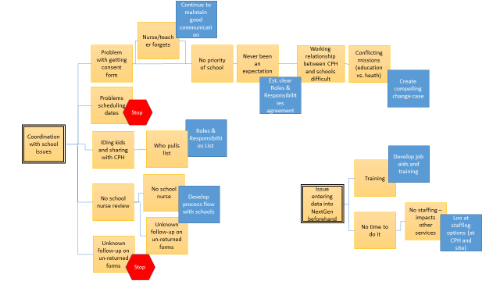

Paste the future state process map and any solution prioritization here.
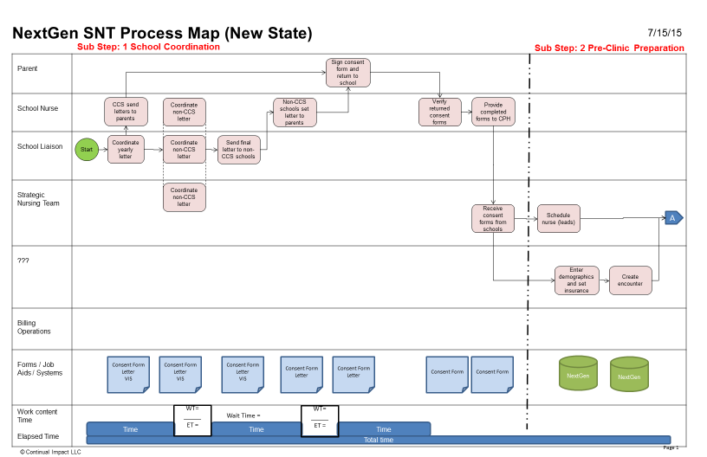
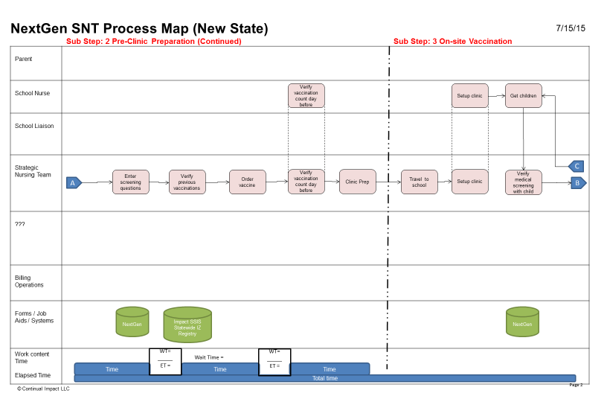
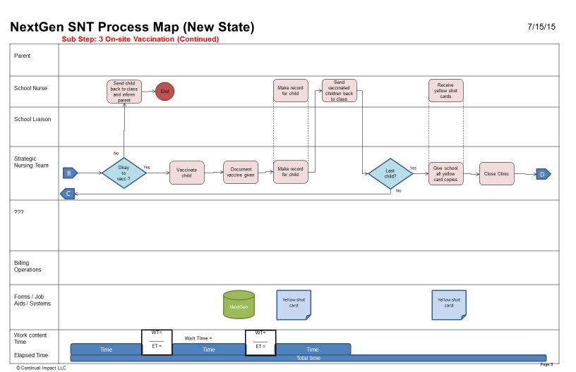
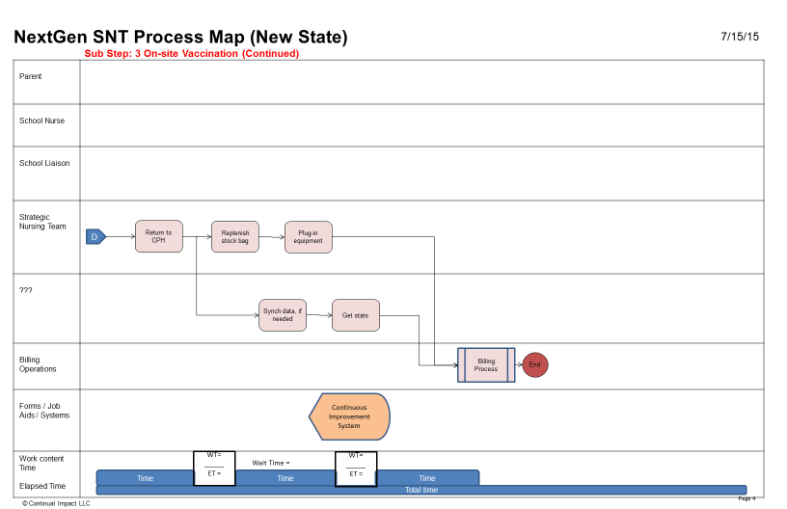

13. Improvement Hypothesis (Summary of potential means to achieve goal)
Issue | Improvement | Expected Results
WORK PROCESS | IF… we reduce work process wastes (label making, waiting for students, clinic setup and teardown), multiple inspection and rework loops found in the current state process…  (About 1700 FTE hours of waste has been identified for this process.) | THEN… work content hours will be freed up to allow re-deployment of contractor work.  (Procurement of contractor labor for data entry $12,000 per year).
SYSTEMS:  Data entry into the NextGen | IF… we create NextGen electronic records earlier in the process, enable the Strategic Nursing Team to access and complete them upon delivery of the vaccination… | THEN…  - redundant manual documentation should be reduced  - large batch sizes and backlogs of records before billing should be reduced (i.e., last submittal to billing done one day after last vaccination)  - error rate should go down due to data providers inputting information
 | IF… we create new standardized work and training materials specifically for the NextGen capabilities used by this process… | THEN…personnel who have not traditionally used NextGen will be able to input data effectively, efficiently and consistently between people.
PEOPLE:  Roles and Responsibilities | IF… we establish agreed expectations, roles and responsibilities with school nurses (what they do, what do we do and what each other needs, e.g. school nurses verifying completing forms)) | THEN… we can better match SNT nurse staffing at schools to amount of immunizations required

_ TRY _
14. Test Hypotheses (How will you test the potential solutions?)
- Update the project schedule For trial and learning)
Tests | How | When | Who | Successful if…
SYSTEMS: Data entry into NextGen system | Have inexperienced user use new training/job aids to enter the following for three test cases:  - Clerical info (enter demographics, create encounter, print shot record  - RN Entry at CPH (enter history, screening questions, order shots)  - RN Entry at site (document vaccination) | 7/16/15  7/16/15  7/16/15 | Laurie  Bob  Bob | All testers are able to complete data entry the first time through without errors or major questions.
 | Have experienced user enter the following for three test cases:  - Clerical info (enter demographics, create encounter, print shot record  - RN Entry at CPH (enter history, screening questions, order shots)  - RN Entry at site (document vaccination) | 7/17/15  7/17/15  7/17/15 | April  Nicole  Nicole | The elapsed time for all three parts of the test must take ≤ 14 minutes
WORK PROCESS and PEOPLE | Using process job aids, simulate the end-to-end process except for the NextGen system entry (tested above separately) | 7/17/15 | Whole Kaizen Team | Job aids allow test performers to clearly execute the process the first time though.

15. Results: paste graph/table of actual trial performance

Area | Test | Test Output | Test Pass/Fail
SYSTEMS: Data entry into NextGen system | Have inexperienced user use new training/job aids to enter NextGen data | Completed steps first time through | Pass
 | Time an experienced user enter NextGen data | Max time for the two test cases was 9mins 44sec | Pass
WORK PROCESS and PEOPLE | Using process job aids, simulate the end-to-end process except for the NextGen system entry | Completed all steps first time through | Pass

_ LEARN _
16. Learning (For the trials, what worked and did not, why and what are you doing as a result? Is the result repeatable?)
Reasons | Learning: Why? | Direction: Actions to be taken
+Pictures/Screen shots helpful | Check sheet/flow diagram would be helpful | Create a high level cheat sheet for entering data so that trained users don’t miss steps
+Notes and job aids were good | Highlighted training materials would be good to find sections quickly | Create down time (paper) process so that system issues don’t stop the clinic
+Knowledgeable people available to help | Two consent forms are needed – can’t combine them | Highlight job aids so that it is easier to find information
+We simulated that the schools were on-board | We need to train performers in full end-to-end process (table top simulation would be good), not just NextGen system | Create role playing Process and NextGen training so that performers understand all roles and have context
-No standardized work flow | Intense NextGen system training will be needed | Update the NextGen manual so that it reflects standard process
-New consent form was complicated | Super User role is going to be very important | Create a filing process with a routing slip that matches process so that important consent forms do not get misplaced
-Process not known by schools yet | Can’t do RN Entry at CPH tasks at school – good it is up front in new process | Create consistency between screening form and NextGen so that users don’t get confused and EMS contains correct data
-Testers did not have any training | Need steps to change vaccine at school
 | Need method to keep consent form paper organized
 | Need to clarify that time is available for RN to check 2nd dose after clinic

_ INSTALL _

17. Installation Plan (Steps to operationalize the new process and make it stick. Attach new process map below.)
- Update the project schedule or Action Items List

What | Recipient | Who will provide | By When
Create a high level cheat sheet for entering data so that trained users don’t miss steps | Process Owner | April/Jane/Bob | 7/31
Create down time (paper) process so that system issues don’t stop the clinic | Process Owner | Sherry | 7/24
Highlight job aids so that it is easier to find information | Melissa | Jen/April | 8/31
Create role playing Process and NextGen training so that performers understand all roles and have context | Process Owner | Sherry/Melissa/Nicole/April/Jane | 8/15
Update the NextGen manual so that it reflects standard process | Melissa | April/Melissa/Nicole/Licia | 7/24
Create a filing process with a routing slip that matches process so that important consent forms do not get misplaced | Process Owner | Sherry | 9/1
Create consistency between screening form and NextGen so that users don’t get confused and EMS contains correct data | Melissa | Nicole/Jennifer  Melissa | 7/24  9/1
Make wish list of needed equipment for new process | Process Owner | All | 7/17 EOD
List of schools to add to NextGen | Melissa | Jennifer | 8/31
Give NextGen training to SNT | SNT RNs | Melissa/April/Licia/Nicole | 8/31
Perform equipment walkthrough | Process Owner | Jane/Sherry | 10/1
ID backup staff | Process Owner | Jane/Sherry | 10/1
Get approval of new letter/consent form for Private/Charter schools | Process Owner | Jennifer/Sherry | 8/7
Get new letter/consent form translated (Spanish, Somali) | Process Owner | Sherry | 8/7
Get multi part IZ cards (City Printer) | Process Owner | Jennifer/Jane | 10/1
Determine how to use “Form Completed By” and “Form Reviewed By” fields in NextGen screening questions. | Process Owner | Jane | 7/24
Go-Live |  |  | 10/1

18. Measure Success
- Attach graph/table of installed performance measures
- Attach photo of current Continual Improvement System

