Project: Infectious Disease On Call Team Satisfaction
Health Promotion
October 2014

PLAN
Identify an Opportunity and
Plan for Improvement

1. Getting Started

The Infectious Disease On Call Team members expressed dissatisfaction with being on the team. Members who wanted off the team could not rotate off, because no one wanted to join the team.

AIM
By July 1, 2015 the ID On Call team’s job satisfaction has increased as evidenced by a 20% improvement in a staff satisfaction survey. (From 14.29% satisfied and 0% very satisfied)

2. Assemble the Team
Cindy Hotchkiss Health Promotion Division Director, Sara Heinemann Outpatient Clinic Supervisor, Dianne Grutch PHN, Amanda Poston PHN, Jenn Kirscher, PHN, Annette VanDomelen, SW, Karyn Johnston, PHN, Colleen Morris PHN

3. Examine the Current Approach
The team used a Current State/Future State tool to discuss ID On Call team current approach.

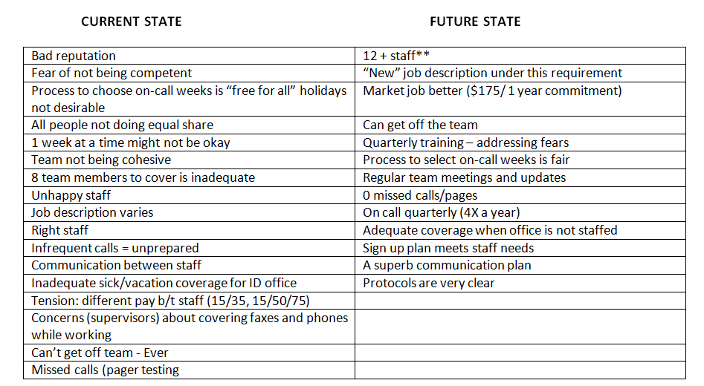

4. Identify Potential Solutions

The team brainstormed 12 factors that contributed to staff dissatisfaction with being a member of the team.
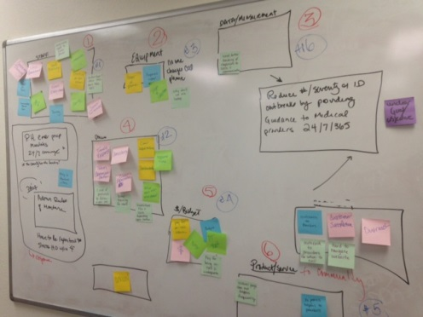

ID on Call staff ranked them, and the QI team decided to focus on the top 5 causes of dissatisfaction. Each one of these became a multifaceted problem to be solved, each with the need for brainstorming, developing an improvement theory and testing the theory.
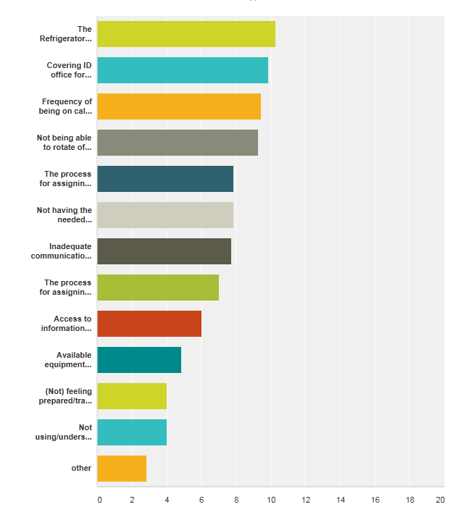
We eliminated the need for ID on call staff to be primarily responsible for moving vaccine in an emergency.
How? A volunteer group was trained by the supervisor to move vaccine. The ID On Call staff is responsible for contacting the group if needed.
We eliminated the need for ID On Call staff to check on the ID office during regular work hours.
How? The administrative staff was trained to check voice mail messages when regular office staff are unavailable for their scheduled shifts. If any of these messages require follow-up, the HP Director or other members of the ID team will be contacted to follow up.
We decreased scheduling frequency by recruiting and training new staff.
How? Recruitment has usually been difficult or impossible. The team drilled down and determined that the reluctance of PHNs to be on this team might stem from fears that the job requires knowledge, skills or time commitment that they aren’t comfortable with. A meeting to discuss the benefits of participating (on call staff receive on call pay), as well as the skills and knowledge needed, and relative ease of providing the service resulted in 4 new team members.
Beginning January 1 2016 existing members will be allowed to rotate off the team.
How? As new members join, existing team members can rotate off based on who has served on the team the longest. The first opportunity to rotate off will be in September.
News members to the team will be generated by providing newly hired PHNs with the education they need to be comfortable being a member of the team if desired. The team’s enhanced reputation will encourage new members as well.
It is also the hope that the increased staff satisfaction will reduce desire to rotate off of the ID On Call team.

Scheduling was addressed.
How? The team was signing up on a calendar and there was no sense of “fairness” about assignments, especially holidays. The QI team developed and tested a plan in which the ID On Call team members sign up for weeks using a survey format and decision matrix that assures a fair assignment of desirable and undesirable weeks of duty.

DO
Test the Theory for Improvement

6. Test the Theory
Each element of the plan was thoroughly tested. For example, 7 drills were done with the volunteer team for vaccine response, including 2 holiday weekends. Three quarterly scheduling cycles were tested. During the testing phase, the ID On Call staff supervisor reported anecdotally that she had stopped receiving complaints from team members.

CHECK
Use Data to Study Results
of the Test

7. Check the Results
The AIM identified was a 20% improvement in staff satisfaction. The outcome was a 530% improvement in staff satisfaction.
In the pre-survey, only one member of the team reported being satisfied, and none were very satisfied. The rest were all dissatisfied or very dissatisfied.
In the outcome survey, NO staff members identified as being dissatisfied or very dissatisfied.

Outcome Survey:
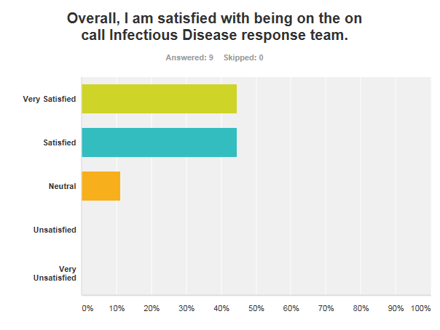

Before and After results:
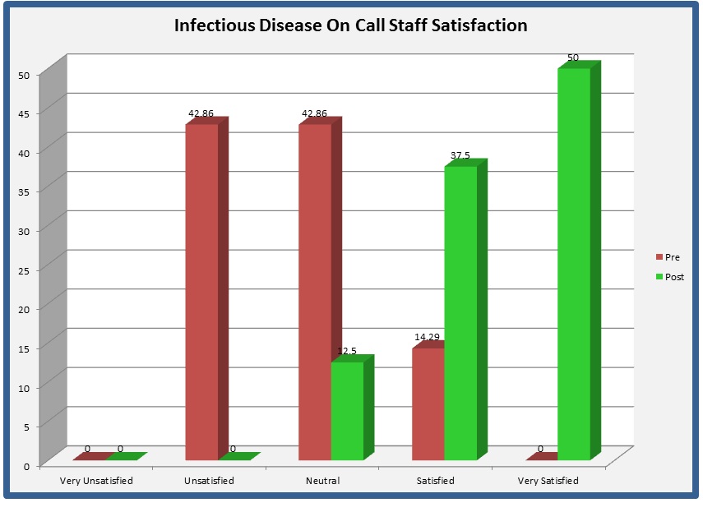

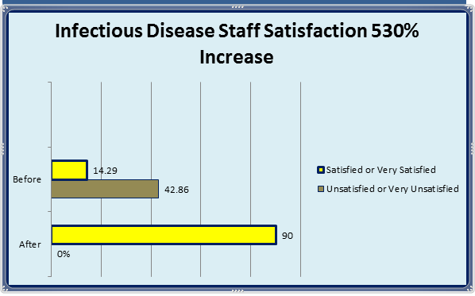

ACT
Standardize the Improvement and Establish Future Plans

8. Standardize the Improvement or Develop New Theory
We adopted the theory and have maintained our results. The ID On Call Team continues to look for ways to further improve and strengthen their team in order to provide Missoula with the best possible response to Infectious Disease concerns.

9. Establish Future Plans
A quarterly drill of the vaccine emergency response volunteers will be conducted.
All newly hired PHNs will receive exposure to the benefits of being a member of the ID On Call Team and be invited to join.
In September 2015, the team member with the longest service will be allowed to rotate off if desired. This opportunity will be provided thereafter every time a new member is recruited. Team members who do not wish to rotate off can pass the opportunity to the next team member in line. The QI team is interested to learn if the staff satisfaction obtained is high enough to eliminate the desire to rotate off of the team, even when the opportunity presents itself.

