WIC QUALITY IMPROVEMENT STORY BOARD 8/15/13

 | WHATCOM COUNTY HEALTH DEPARTMENT | QI Team: Kelly Molaski, Nutrition Services Supervisor
 | 509 Girard Street, Bellingham, WA, 98266 | Judy Ziels, Parent Child Health Supervisor
 | (360) 676-6724 | Susan Sloan, Performance Management Specialist
 | 75 employees, serving a | Allison Williams, WIC Certifier
 | population of 201,140 | Astrid Newell, Community Health Manager
 |  | 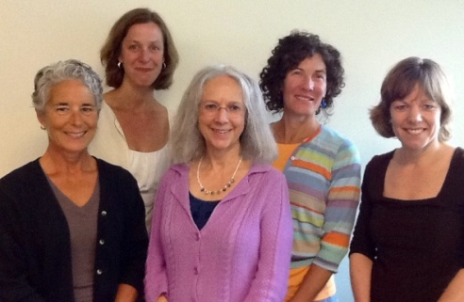
qi project: | improving wic scheduling efficiencies
 | using quality improvement techniques

DEFINITIONS:
WIC: A supplemental food and nutrition education program for eligible low-income women, infants, & children.
Second Education Contacts (2C’s): Required nutrition education provided to WIC participants.
No show: A missed appointment.

PLAN
Identify an opportunity and
Plan for Improvement

1. Getting Started
Our overall goal was to increase the number of WIC-eligible clients served by maximizing use of available appointment time. As of July 2013, there were 1,966 WIC-eligible individuals on Medicaid in Whatcom County who were not participating in a WIC program. These individuals miss out on $600 worth of food each year plus the nutrition education benefits of WIC.

2. Assemble the Team
Our diverse team included WIC supervisory staff, a WIC certifier, and our QI facilitator. We received monthly technical support from DOH’s Centers for Performance Management Excellence as part of a $10,000 QI grant.

3. Examine the Current Approach
We focused our efforts on process improvements to increase scheduling efficiencies and improve customer satisfaction.
AIM STATEMENT:
By August 1, 2013, increase the number of eligible WIC clients served by maximizing use of available appointment time.

The team conducted a detailed
review of
the VFC

- The team identified the root cause of missed client appointments: 52% forgot the appointment (13 of 25).

- Of all clients, 2C’s had the highest “no show” rate of 32%.

4. Identify Potential Solutions
The following potential changes were identified:
- Improve our client appointment reminder system by calling two days before the appointment rather than the current practice of calling one day before.
- Provide 2C clients with additional options for nutrition education that do not require a formal one-on-one appointment with a WIC certifier.
5. Develop an Improvement Theory
- If we reduce no show appointments then our overall caseload will go up.
- If we have fewer 2C clients needing 15-minute one-on-one appointments with a WIC certifier, then we will have additional appointment time available for new clients.

DO
Test the Theory for Improvement

6. Test the Theory
- For a period of 3 weeks our clerk called clients two days before the appointment as a reminder.
- A client Education Room was created to accommodate clients preferring this option to a 15-minute in-person meeting. Clients were surveyed regarding their experience.

CHECK
Use Data to Study Results of the Test

7. Study the Results
- Calling clients two days prior to an appointment did not improve “no show” rates. Unfilled time increased for certifiers from 11% to 15%.
- We estimate that between 360-720 clients will use the Education Room annually (15 minutes of certifier time saved per client) for an annual cost savings in the range of $3,500-$7,000.
- 61% of the clients surveyed appreciated the convenience of the Education Room option.

ACT
Standardize the Improvement and Establish Future Plans

8. Standardize the Improvement
or Develop New Theory
The Education Room option will expand to serve WIC clients who have missed their appointment as well as scheduled 2C’s. An at-home online education option will be offered also.

9. Establish Future Plans
- Improve the accuracy and efficiency of WIC data collection.
- Explore the feasibility of text messaging appointment reminders to clients.
- Create an effective marketing plan to attract new WIC-eligible clients.

