

Our Mission: The Cerro Gordo County Department of Public Health works to optimize the health of all people in Cerro Gordo County.

**Improving Immunization Data Entry Timeliness into State Registry**

March 22, 2017 – January 9, 2018

**Background**

The Cerro Gordo County Department of Public Health’s Acute Infectious Disease Department administers over 2,000 of Influenza, Pneumococcal Conjugate (PCV13) and Polysaccharide (PPSV23) vaccinations during the months of September, October and November. Immunizations are administered by 1 full time nurse position at our walk-in immunization clinic and 1-3 nurses and support staff at 70+ outreach influenza clinics within the county. The outreach locations include senior centers and residential living facilities, schools, daycares and businesses. Many of the outreach influenza clinics are scheduled outside of normal working business hours. Other job responsibilities have to continue in addition to these services which negatively impacted our staff morale and data entry timeliness into the Iowa Immunization Registry Information System (IRIS). Timely data entry of all vaccinations administered is not only a best practice but important for other healthcare providers to know particularly for children who need a 2nd influenza vaccine booster.

**The Team**

Team Leader: Bethany Bjorklund, Immunization Nurse

Scribe: Jennifer Stiles, Assistant Service Section Manager

Team Member: Jodi Willemsen, Service Section Manager

Team Member: Sandy Pals, Administrative Aide

Team Member: Betty Krones, Disease Prevention Specialist

Team Member: Valerie Conklin, Family & Community Health Service Manager

Team Member: Samantha Smith, Disease Prevention Specialist

QI Coordinator/Facilitator: Kara Vogelson, Organizational Development and Research Manager

**PLAN-** March 22, 2017 – August 30, 2017

**Problem Statement:** IRIS data entry for influenza, PCV13 and PPSV23 vaccinations beyond 7 days from September 1 through November 30, 2016 was 57%. An increase from 2015 data entry timeliness by 50%. Previous year’s data entry timeliness for the same vaccinations was 10% in 2015 and 2.81% in 2014.

**Original AIM Statement:** IRIS data entry for patients served by Cerro Gordo County Department of Public Health who receive influenza, PCV13 and PPSV23 vaccinations from September through November 2017 will not exceed 5% over 7 days.

*During our first team meeting a representative from the Iowa Department of Public Health was shadowing our QI planning meeting and recommended our AIM statement to be checked midway through with an obtainable goal.*

**Revised AIM Statement:**

Documentation into state immunization registry for patients served by Cerro Gordo County

Department of Public Health who receive influenza, PCV13 and PPSV23 vaccinations from:

September 1, 2017 through October 15, 2017 will not exceed 25% over 7 days and

October 16, 2017 through November 30, 2017 will not exceed 5% over 7 days.

**Current Approach**

There was no standardized procedure and established staff responsibilities in place for this program. Each staff member had various levels of expectations as to what their role was and when those tasks should be completed. Prioritizing data entry for influenza was put on the bottom of mostly everyone’s to-do list due to other roles and responsibilities. In the past, timely data entry for influenza vaccines was not a priority and sometimes was not entered into the Iowa Immunization Registry until the following spring. Team work and staff morale historically was poor during this time of year for many years prior to this project which started to impact our program negatively beyond a couple of months. The year previous 2016, the team was short staffed with 1 nurse on maternity leave, an infectious disease outbreak and back to school immunizations. This project allowed the team to sit down and discuss their frustrations that directly impacted our AIM statement. After a couple meetings a formal contract was created by the Service Section Manager asking for each team member to sign and hold each other accountable for the tasks assigned to them and to ask for help and to identify solutions to the problems at hand.

**Identify Potential Solutions**

Due to the history of this subject, minimal time was spent identifying problems. We immediately started brainstorming solutions to improve our problems. QI tools were utilized to identify a wide array of possible solutions.

**Solutions chosen:**

1. Define staff roles and responsibilities.
2. Provide onsite access to data entry through employee surfaces and multi user hot spot.
3. Beef up staffing at large outreach clinics. Bring in outside service section help, if needed.
4. Establish responsibility and ownership.
5. Have a competent team approach.

Emphasis was made to all team members to utilize and follow the QI tools developed before making any changes to the process prior to our first check-in meeting. Following the tools created would distinguish if any problems occurring were due to the actual process/tool developed or because of personal choices to not complete an assigned task.

**QI Tools Used (pages 3-7):**

* Brainstorming
* Solution and Effect Diagram
* Impact Difficulty Matrix
* Nominal Group Technique with Multiuser Voting
* GANTT Chart
* Roles and Responsibilities Diagram

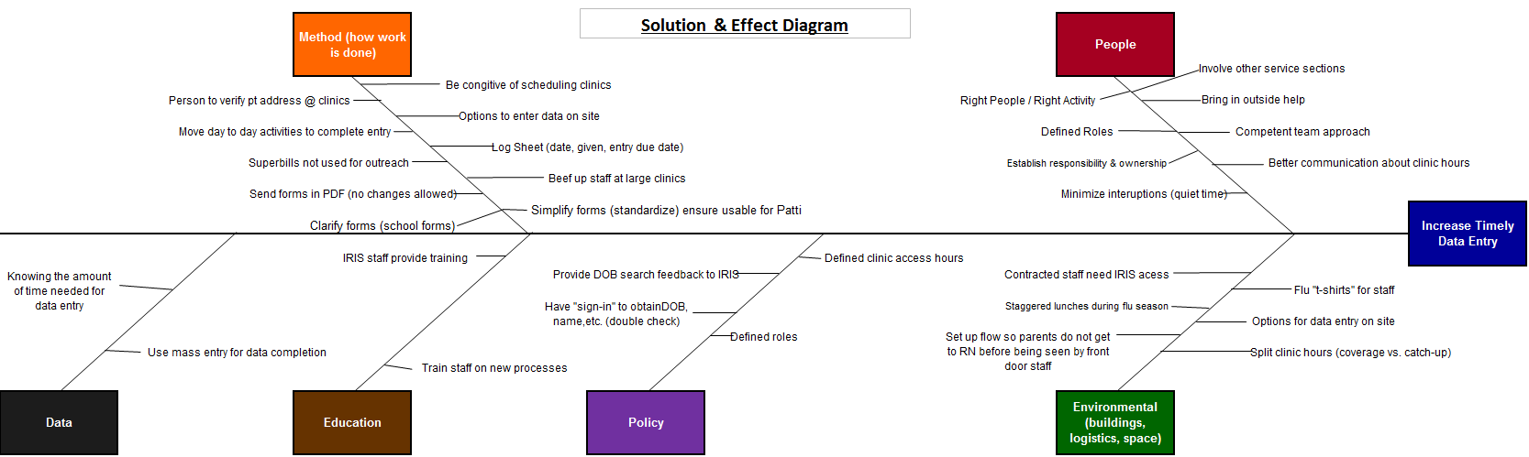





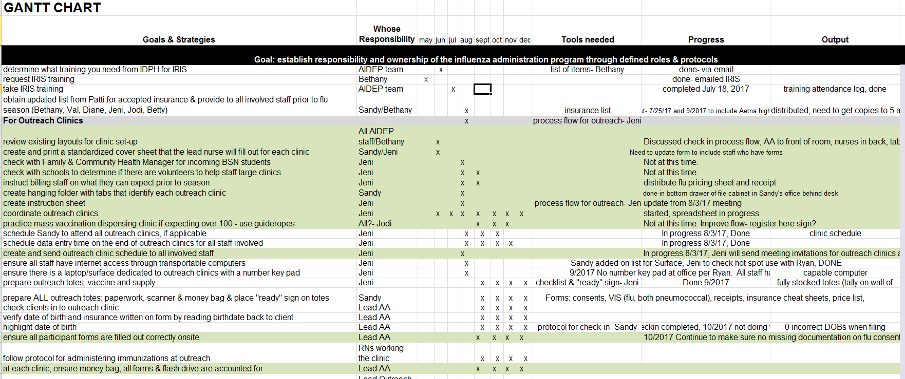

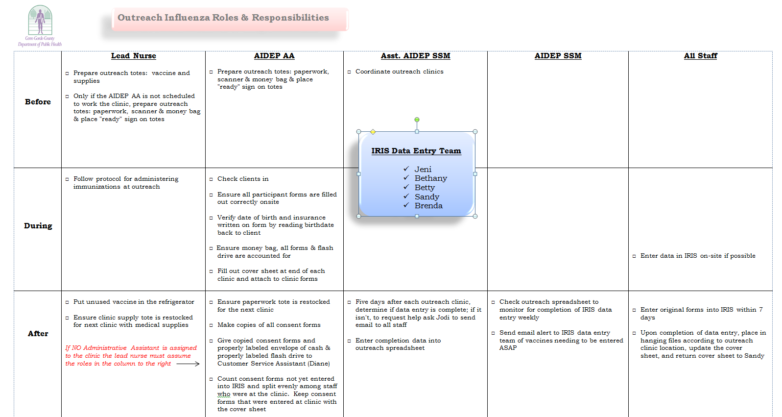

**DO- September 1, 2017 – November 30, 2017**

**CHECK- 10/15/2017 and 11/30/2017**

The team checked their progress twice during the course of this project.

**1. AIM Statement 9/1/2017 – 10/15/2017**

Documentation into state immunization registry for patients served by Cerro Gordo County Department of Public Health who receive influenza, PCV13 and PPSV23 vaccinations **will not exceed 25% over 7 days.**

|  |  |  |  |
| --- | --- | --- | --- |
| Total Vaccines Given | Total # Exceeding 7 days | % Exceeding 7 days | Goal |
| 2,018 | **34** | **1.68%** | **25%** |

**2. AIM Statement 10/16/2017 – 11/30/2017**

Documentation into state immunization registry for patients served by Cerro Gordo County Department of Public Health who receive influenza, PCV13 and PPSV23 vaccinations **will not exceed 5% over 7 days.**

|  |  |  |  |
| --- | --- | --- | --- |
| Total Vaccines Given | Total # Exceeding 7 days | % Exceeding 7 days | Goal |
| 1,035 | **7** | **.68%** | **5%** |

**Overall Project Statistics: September 1, 2017 – November 30, 2017**

|  |  |  |  |
| --- | --- | --- | --- |
| Total Vaccines Given | Total # Exceeding 7 days | % Exceeding 7 days | Goal |
| 3,053 | **41** | **1.34%** | **5%** |

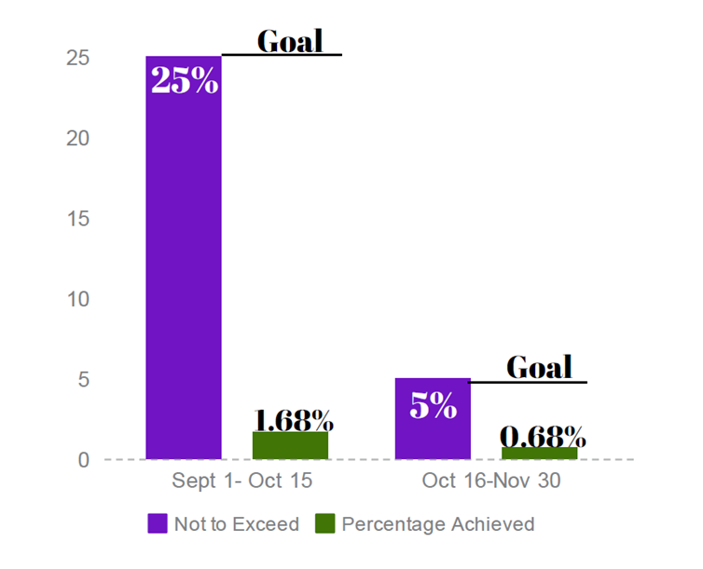

**GOALS MET**

**Successes:**

* The team completed **55** outreach influenza clinics, including the largest schools and businesses to account for **66%** of the total flu and pneumococcal vaccinations administered prior to the first check in meeting.
* Majority of IRIS data entry was completed at outreach sites on employee Surfaces. A multi user internet hot spot was utilized so that all staff with Surfaces could enter immunizations into registry.
* Dividing data entry for the large outreach flu clinics (i.e. 90-140 vaccines given) among staff made our data entry timeliness less than 7 days. This process also helped lighten the workload for all team members, making data entry easier and faster to complete so staff could focus their time on other responsibilities.
* Adding a second AA and third nurse at the largest school based flu clinic created a better work flow for staff and the families served by our agency. The nurses were able to focus on administering vaccines while support staff could help direct those receiving vaccines.
* Staffing the Immunization Clinic with the primary nurse and front console staff allowed the AIDEP AA to assist the nurse assigned to the outreach clinic.
* One grant for the immunization program was written to not include services for the months of September and October if time did not allow. This allowed the immunization nurse covering the immunization clinic the capability to keep up with IRIS data entry.
* The tools created by team members were readily accessible so all staff knew their roles and responsibilities.
* Iowa’s IRIS Data Exchange Specialist quickly provided data for this project via email communications.

**Barriers:**

Two specific processes were identified as the sources of data entry exceeding 7 days.

From September 1, 2017 – November 30, 2017 this included only **41 out of the 2,971** total vaccines given.

1. Outreach employee flu vaccines administered at the jail had no established process in place. The nurse at the jail administers flu vaccines to county employees and is not set up to enter vaccines into IRIS. The team prefers to do the data entry and the consent forms must come back to our office for record keeping and billing.

* Modifications made: Immunization Nurse outreached to jail nurse to determine when consent forms could be picked up weekly. Jail Nurse scheduled specific days/times for employees to see her for a flu vaccine. Email follow up was done the Monday following the scheduled employee flu vaccine clinic. Team will discuss possible ideas for improvement at the 2018 flu planning meeting.

2. Public Health Nurse Flu consent form turn-in bin was not being checked daily.

* Modifications made: Immunization Nurse began checking the immunization consent bin daily after a public health nurse contacted her several times that consents were not being picked up daily. Team will discuss possible ideas for improvement at the 2018 flu planning meeting.

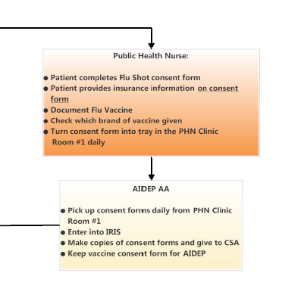

**Immunization Clinic Client Flow Chart, 9/18/2017**

**Other Barriers:**

* Outreach clinic cover sheets were not always completed.
* Modifications made: AIDEP AA modified outreach clinic cover sheet.
* Daycare outreach flu consent forms did not list age in years making it difficult for staff to determine child’s age and the appropriate dosage.
* Modifications made: Immunization Nurse will update flu consent forms to include the age of child.
* VFC screening eligibility documentation was lacking on the top of influenza consent forms. This increased data entry time in IRIS since VFC screening documentation is required.
* Modifications made: Immunization Nurse will add VFC eligibility criteria to the top of the 2018-19 flu vaccine consent forms to speed up data entry in IRIS.

**ACT**

**Future Plans**

* A GANNT chart will be utilized for the 2018-19 influenza vaccine season to help all staff know their role and when tasked assigned to them are due by.
* Clinic Cover Sheet and 2018-19 Influenza Consent forms will be updated to include areas of improvement.
* Team will re-evaluate the Public Health Nurse and Outreach Jail Flu vaccine administration process for timely data entry.
* Data entry timeliness will be checked on October 15, 2018 and November 30, 2018 to determine if AIM statement is being achieved or to help identify areas of improvement.
* Brainstorm ideas on how to improve insurance information collection at outreach clinics.
* Continue to hold ourselves accountable for creating a positive team approach.

**Sources of Data**

* Iowa Immunization Registry Information System (IRIS)

*A special thank you to the IRIS Helpdesk staff for assisting in data collection for this project!*