2012 Community Health Conference
Strengthening Public Health: Linking Past Success to Future Challenges
Thursday, October 4, 2012
Concurrent Session: Series A

PHABulous Response with Brenda Pohlman, BS, MPH

Learning Objectives:
- Understand PHAB Standard 2.1 criteria related to investigating health problems and environmental public health hazards.
- Learn how to access and utilize quality improvement methods and tools that align with PHAB Standard 2.1.
- Be able to apply a continuous improvement tool to a health problem, environmental public health hazard, or another public health issue.

Session Description:
This session will share how the process of quality improvement can be utilized to meet PHAB standards within a rural health department. Information regarding resources, tools, and partner engagement in improving response time to health problems and environmental health hazards will also be shared. Participants will be able to practice utilizing continuous improvement tools and will receive access to the Fillmore County model for responding to health problems and environmental health hazards.

Public Health Accreditation:

Domain 2: Investigate health problems and environmental public health hazards to protect the community. Domain 2 focuses on the investigation of suspected or identified health problems or environmental public health hazards. Included are epidemiologic identification of emerging health problems, monitoring of disease, availability of public health laboratories, containment and mitigation of outbreaks, and coordinated response to emergency situations, and communication.

Standard 2.1: Conduct timely investigations of health problems and environmental public health hazards.

2.1.1 A: Maintain protocols for investigation process (Written staffing plan and protocols).
2.1.2 T/L: Demonstrate capacity to conduct an investigation of an infectious or communicable disease (Case Reviews and After Action Reports regarding organizational capacity).
2.1.3 A: Demonstrate the capacity to conduct investigations of non-infectious health problems, environmental, and/or occupational public health hazards (Documented investigation report)
2.1.4 A: Work collaboratively through established governmental and community partnerships on investigations of reportable/disease outbreaks and environmental public health issues (Official written agreements, after action reports, and laboratory listings).
2.1.5A: Monitor timely reporting of notifiable/reportable diseases, lab test results, and investigation results. (Tracking log for lab and investigation results and documentation of relevant laws).

Potential Health Problems and Environmental Public Health Hazards:
- Foodborne outbreaks
- Infectious disease outbreaks
- Public health emergency response
- Public health nuisances

Continuous Improvement Tools:
- Continuous improvement involves assessing the situation, decision making, and implementing a program.

Fishbone Diagram Tree Diagram Plan-Do-Study-Act (PDSA)
(Cause and Effect Diagram) (Rapid Cycle Improvement)
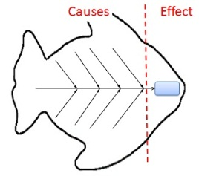
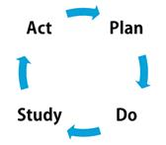
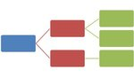

Resources:

Minnesota Department of Health Office of Performance Improvement
http://www.health.state.mn.us/divs/cfh/ophp/index.html

National Network of Public Health Institutes – Accreditation and Performance Improvement
http://www.nnphi.org/program-areas/accreditation-and-performance-improvement

Public Health Accreditation Board (PHAB) - Standards and Measures
http://www.phaboard.org/accreditation-process/public-health-department-standards-and-measures/

Public Health Foundation (PHF) - Performance Management and Quality Improvement http://www.phf.org/focusareas/PMQI/Pages/default.aspx.
Fillmore County Public Health
Brenda Leigh Pohlman, BS, MPH
Health Educator
902 Houston Street NW, Suite 2
507-765-2636
bpohlman@co.fillmore.mn.us

