Engagement of Customers, Stakeholders, and Team Members in QI Projects: Effective Tools for Gaining Support of Those Who Matter

QI tools and strategies to assist with engagement

Recognize all stakeholders.

Who is currently involved in the process?

Who is contributing time and resources?

Who will be impacted by the project?

Example: Our QI Team

Data Collection

What do you want answers to?

Who has these answers?

Who is going to evaluate and process the results of the data collection?

C. Meeting evaluations
1. Embracing Quality in Public Health: A Practitioner's Quality Improvement Guidebook
Assess and address the morale of the QI team—a safe way to raise concerns and give out kudos.
This can be a verbal or written exercise that takes 2-3 minutes.

Example of an evaluation from RiverStone’s meetings:
Meeting Evaluation

Did we address the agenda?

Did we meet the goals for our meeting?

After this meeting, how do you feel about the projects progress?

Rate today’s meeting from 1-10. (10= best possible meeting). _____________

- Flowcharts
Creating a flowchart is an opportunity to involve team members and “front-line” individuals in building or re-defining the process to identify gaps and opportunities for improvement.

Flowcharts examine the perceived process versus the actually process. Once the QI team develops a flowchart, this could be presented to staff who are involved in the process on a regular basis. They often have insight that is not captured within the small QI team.

Steps to creating a flowchart:
- Define the input and output.

- Determine all steps involved.

- Arrange steps in the order they actually occur-not how they should occur.

- Create the flowchart using symbols and arrows as appropriate to create an easy to use visual that can be referenced throughout the QI project.

See an example of a flowchart on the following page.

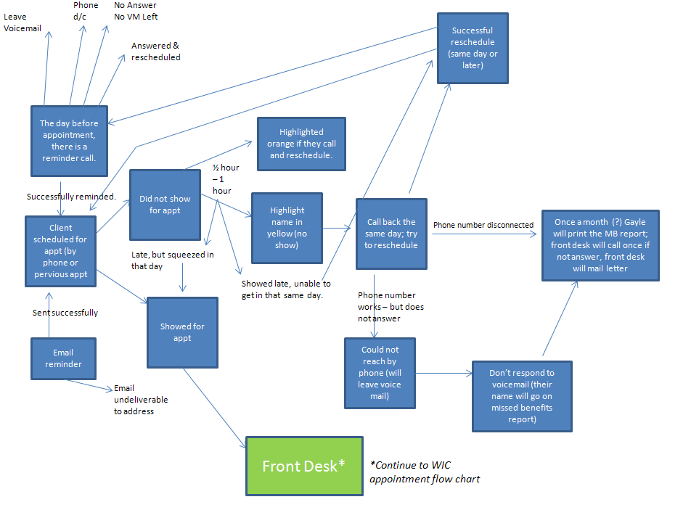
- Brainstorming
Group brainstorming builds trust, promotes participation of all team members, and is time-efficient.
When beginning to brainstorm, the following questions can be posed to the group to begin to examine and more fully understand the process:
- What are we doing now?
- How do we do it?
- What are the major steps in the process?
- Who is involved?
- What do they do?
- What is being done well?
- What could be done better?
- How long does this process take now?
- Is it efficient? Is there variation in the process?
- Is our process stable?
- Are we doing the right things, the right way?
- Are we consistent? What is the cost?
- What is the trend over time?
- Are we meeting our goals?

One activity to encourage effective and efficient brainstorming in a safe manner is a silent form of brainstorming. Each team member starts with a blank sheet of paper and for 4-5 minutes jots down ideas that they have based on the brainstorming topic. When time is up, the paper is passed to the person on the right. Time is started again for 3-4 minutes and team members have a chance to build on the ideas already on the paper, or perhaps include a new idea they might have. This exercise is continued until each member has their original sheet of paper in front of them again. This allows for group participation, and no one is left out of the brainstorming or controls the discussion.

- Group Decision Making
Use a form of weighted multivoting to allow for each team member to be part of the decision making.

Example form from RiverStone’s project:
Best of luck with your project!

For further questions or discussion please contact Hannah Silveus or Hillary Hanson at RiverStone Health.
- Hannah: hannah.sil@riverstonehealth.org
- Hillary: Hillary.han@riverstonehealth.org

