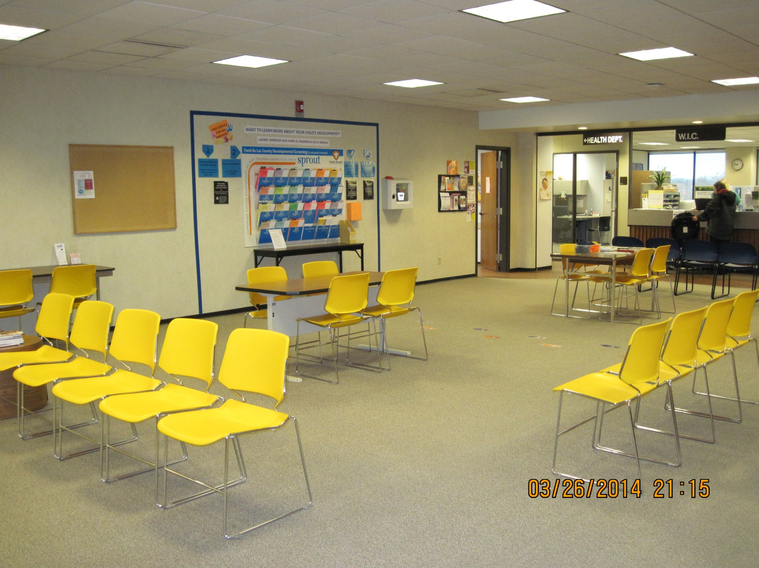

iPad

Less clutter  
overall

Moved chairs according to color

Removed unneeded chairs from waiting area

Clear directions including Spanish

Footsteps leading to display