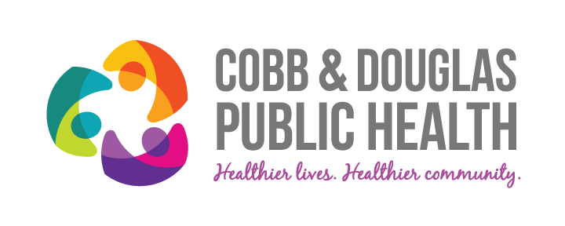
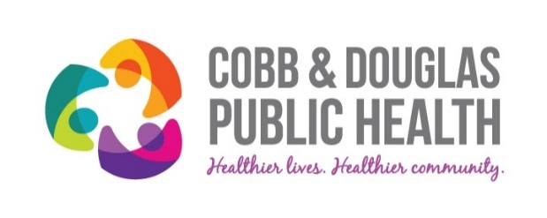

CERTIFICATE OF COMPLETION

This certificate is awarded to
Danielle Sanders
For successful completion of
Quality Improvement 101: Basics
Held on 4-20-17 at Cobb & Douglas Public Health

___________________________________________________ ___________________
Gurleen Roberts, Director of Quality Management Date

