GOLDEN Q TEAM AWARD PROGRAM GUIDELINES

DESCRIPTION
The “Golden Q Award” recognizes a Cobb & Douglas Public Health (CDPH) team who has achieved significant and positive results through quality improvement efforts.

SELECTION
Nominations will be reviewed by the Quality Council. One team will be selected and recognized for the award during the nomination year (April-March). The award will be presented at the Annual CDPH Conference in May.

ELIGIBILITY
Any group of CDPH employees that have actively worked together to improve a process are eligible to be a part of the team considered for this award.

QI project teams consist of multidisciplinary individuals who actively work together to improve a shared process. This award recognizes collaborative teams that have completed robust projects resulting in significant and sustainable process improvements. Scoring will be based on the following weighted criteria, which must be reflected on the QI project storyboard. Scoring guide is available on page 2.
- Completion of storyboard content
- Organization of storyboard
- Whether the AIM statement was SMART and challenging
- Percentage of improvement from baseline data to post-data (Results)
- Number of QI tools used in addition to the PDSA framework
- Number of PDSA cycles and/or projects conducted
- Amount of money saved and/or generated for the agency (directly or indirectly)

PROCEDURES
Nomination will be accepted electronically at this link by March 31, 2017: https://form.jotform.com/31886117371154.
- Please be prepared to upload your best QI project storyboard.
- Please obtain approval from center director(s) supervising team members prior to applying.
- All former recipients of the award shall remain eligible in succeeding years to receive the award.
- Any CDPH employees can nominate themselves, and/or as many teams as desired.

AWARD
Awardees will receive the following:
- 1 rotating Golden Q trophy to display in the team’s work area during the award year
- Certificate of recognition for each individual
- An article mentioning the team’s QI efforts in the CDPH Spotlight newsletter
- A team pizza party to celebrate or up to $100 gift card for restaurant of choice

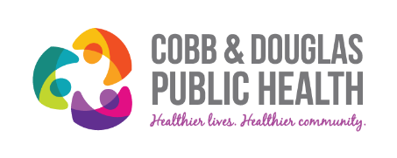

Scoring Guide for the Golden Q Award

Team Name: |  | Process:
Criteria |  | Total | Comments
- Storyboard Content
3 = complete
2 = incomplete
1 = missing
- Storyboard Organization (clear, consistent, professional, visually appealing, captures interest)
3 = Well organized
2 = Somewhat organized
1 = Minimally organized
0 = Not organized
- AIM Statement
3 = SMART and challenging
2 = SMART but not challenging
1 = not so SMART
0 = no AIM Statement
- Results
9 = Achieved significant results compared to
AIM statement
6 = Achieved minor of results compared to AIM
statement
3 = Did not achieve results listed in AIM
statement
0 = Results were not clear
- QI Tool Usage (other than the PDSA framework)
3 = QI tools were used and are displayed on
storyboard
2 = QI tools seem to be used but are not
displayed on storyboard
1 = QI tools were not used
- PDSA Cycles
3 = 2+
2 = 1
1 = Incomplete cycle. Only did “Plan” and “Do” sections, not “Study” or “Act”
- Money saved/generated
3 = Money was saved/generated
2 = Inkind/indirect funds were saved/generated
1 = No direct/indirect funds were
saved/generated
Total Points (27 max):

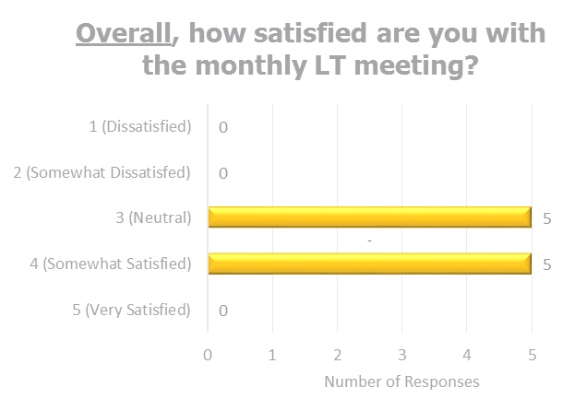
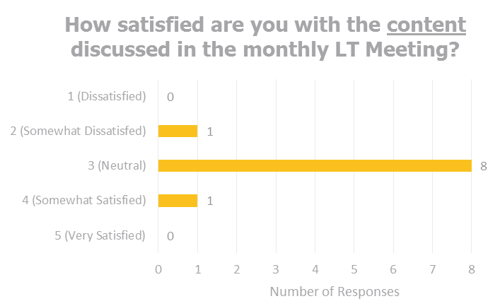
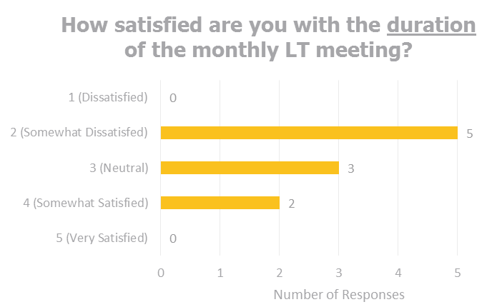
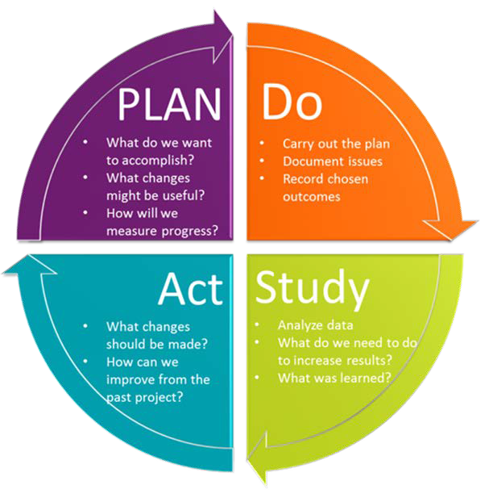
EXAMPLE

