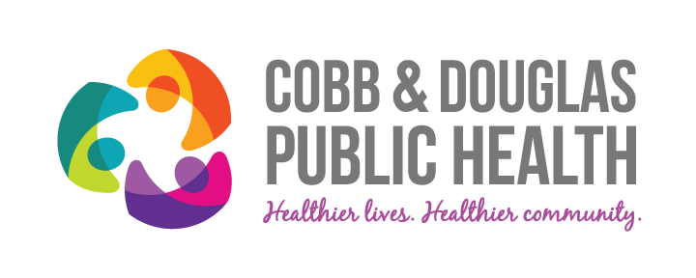
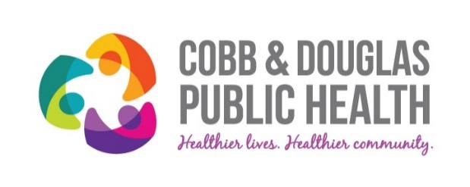

THE GOLDEN Q TEAM AWARD

is presented to

For being a part of the (insert name) Team, who achieved significant and positive results through quality improvement efforts during Fiscal Year 2017.

___________________________________________________ ___________________
Gurleen Roberts, Director of Quality Management Date

___________________________________________________ ___________________
Dr. Jack Kennedy, District Health Director Date

