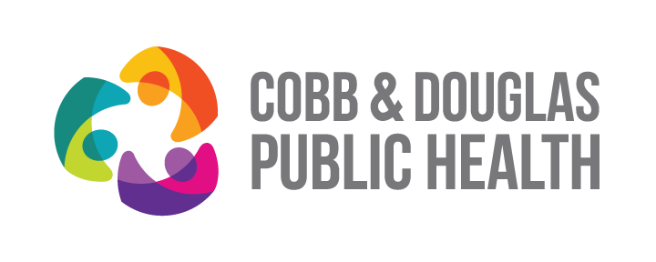
CDPH Team and Workgroup Charter Guidelines:

Charter Template sections are numbered to conform with this guidance/instruction document.

- Purpose: Why is this group being formed?
  - What is (are) the problem(s) being addressed?
  - What are the expected benefits, deliverables, outcomes or results or deliverable(s) for CDPH?
  - Why are these important?
  - Linkages to key CDPH Plans or PHAB requirements?
    - e.g. Workforce Development Initiative: WFD Plan and PHAB Domain 8
- Date Formed: Date assigned or authorized by supervisory staff
- Smart Goals: Goals should be Specific, Measurable, Attainable, Relevant, and Time-Bound
- Out of Scope: When applicable, define boundaries/limits of of project(s)
- Team Meetings:
  - Meeting Frequency: e.g. monthly
  - Meeting Schedule – e.g. 2nd Wednesday of each month @ 10 AM
  - Meeting Length: e.g. one hour
- Membership:
  - Standing members:
    - Are assigned roles and responsibilities
    - Attend all meetings
  - Ad hoc members: (Not listed). Appointed as required by Team Chair/Leader

