Alaska Division of Public Health Quality Improvement Plan

1. Executive Summary

Purpose
The purpose of the Alaska Division of Public Health (DPH, Division) Quality Improvement (QI) Plan is to provide a context and framework that will assure an environment and culture of continuous quality improvement (QI) throughout the Division. Successful implementation of this plan will increase efficiency and effectiveness of activities within the division, increasing DPH’s ability to protect and promote the health of Alaskans and Alaska communities across the state.

Objectives
The primary objectives of the quality improvement plan are to:
- Increase QI competence of DPH staff
- Improve Division wide performance through use of the QI process.
- Align individual QI activities with Division’s priorities, DHSS performance measures, and the PHAB standards
- Create a culture of quality

Overview
Four strategies are being used to create a Division-wide culture of QI. Key strategies include integration of QI within the DPH performance management system, increasing staff competency through training and technical assistance, strategic communications, and QI evaluation. Integrating QI into DPH Performance Management System assures alignment of QI projects with Division and Department priorities and aids in identification of critical goals and measures for success. Training and ongoing technical assistance will increase staff’s ability to improve activities using QI processes. Ongoing communications will increase successful implementation, deepen staff awareness of available resources, and celebrate QI successes. Operationalizing these key strategies will provide transparency of identified gaps and successes, allowing for continuous program improvement. Evaluating QI efforts of the division will help monitor progress and successes of QI initiatives and identify additional training and technical assistance needs.

Policy Statement
DPH will implement and maintain a QI system, including a plan, inclusive of DPH’s programs, interventions, and processes as part of the agency’s performance management system. The plan will be reviewed and updated on an annual basis.

Quality improvement efforts are critical at all levels of the division to achieve our mission to protect and promote the health of Alaskans. I am committed to supporting a culture of quality to achieve long-term success. However, a culture of quality cannot exist without the individual commitment of all division staff utilizing quality improvement in day-to-day activities. This Division-wide QI Plan provides the framework to empower employees to identify ways to improve processes and outcomes while fulfilling accreditation requirements of the Public Health Accreditation Board. The resulting efforts will enable the division to enhance performance and its ability to improve the health of Alaskans. – Jay Butler, MD, Chief Medical Officer and Director – Division of Public Health.

Introduction and Alignment
This AK DPH Quality Improvement Plan was developed and will be implemented within the context of a variety of other initiatives and frameworks, all of which share a focus on standards, measures, and/or targets, and each of which contribute to a culture of quality. The intent of this alignment around quality is that a culture of quality supports more efficient, effective DPH employees, with the ultimate result of improved health for Alaskans.
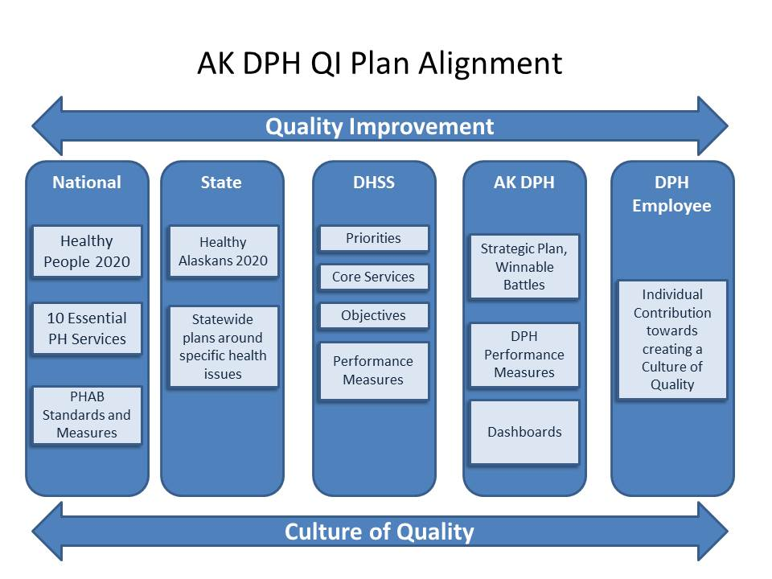

Definitions
In an effort to establish a common language around quality improvement within AK DPH, this plan defines key QI terms in the following manner:

Performance Management
“Performance management identifies actual results against planned or intended results. Performance management systems ensure that progress is being made toward department goals by systematically collecting and analyzing data to track results to identify opportunities and targets for improvement.” (PHAB, 2014, p. 203)
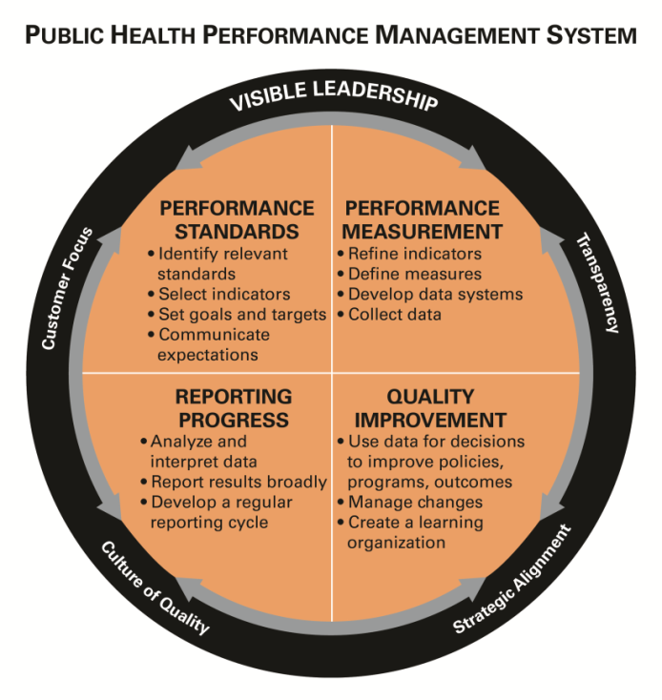

Quality Improvement
Quality improvement in public health is the use of a deliberate and defined improvement process, such as Plan-Do-Check-Act (PDSA), which is focused on activities that are responsive to community needs and improving population health. It refers to a continuous and ongoing effort to achieve measurable improvements in the efficiency, effectiveness, performance, accountability, outcomes, and other indicators of quality in services or processes which achieve equity and improve the health of the community. (Riley, Moran, Corso, Beitsch, Bialek, and Cofsky. Defining Quality Improvement in Public Health. Journal of Public Health Management and Practice. January/February 2010).

Quality Assurance
“The planned and systematic activities implemented in a quality system so that quality requirement for a product or service will be fulfilled.” (American Society for Quality, n.d.)
Quality assurance is often thought of as assuring the minimum or standard has been met. It may be part of quality improvement if the information collected is fed into a process where it is used to increase the quality minimums or improve processes, PDSA cycle provides process structure to build increased quality.
A number of organizations have compiled listings and definitions of additional quality terms, such as PHAB in its Acronyms and Glossary of Terms 1.0 and ASTHO in its National Public Health Performance Standards Version 3.0 Glossary.

3. Overview of Quality in the Agency
In September of 2015, the DPH Q Team conducted a self-assessment using the Roadmap to a Culture of Quality Improvement assessment tool from the National Association of County and City Health Officials (NACCHO). Based on this assessment, it was determined that DPH is currently in the intermediate phase of creating a culture of quality. The Q-Team is in place to provide oversight of a Division wide plan; essential gaps have been identified, and plans are in place to move towards creating an organization wide culture of QI. As illustrated in the diagram above, QI is an essential component of a performance management system. In addition to the Q-Team, ad hoc QI activities are being conducted throughout the division and three sections have formal QI programs. However, previous to this plan there has not been a formal coordinated, division wide implementation of a QI system and, as a result, DPH has not yet achieved a culture of quality.
A few essential components must initially be in place to meet this overall objective:
- A comprehensive performance measurement system must be in place
- Division wide leadership support must be assured
- A communication plan has to be developed and implemented, and staff must be trained
- An evaluation plan has to be created and strategies need to be identified to ensure sustainability

Once those components are in place, ongoing guidance, encouragement, training and communications will be needed to maintain a Division wide culture of QI. Finally, the DPH QI program itself will require a regular self-evaluation to assess its effectiveness.

4. Governance Structure
Division of Public Health leadership is responsible for the quality of services delivered throughout the Division. Division leadership provides general direction and delegated the development and implementation of a quality improvement program to the Division of Public Health Quality Team “Q Team”. The Q Team was established in 2013 to support a culture of quality improvement within the Division and to promote quality improvement efforts Division-wide. The Q Team’s vision—that the Division of Public Health is highly functioning and well-resourced to support the health of Alaskans and Alaskan communities—will be reached by execution of the Q Team’s mission:
To support QI efforts across the Division of Public Health through sharing QI expertise, encouraging use of QI, and promoting a culture of quality improvement.
As such, the Q Team itself will not be responsible for overseeing or implementing all Division-wide QI efforts; rather, it will serve in a supportive role, sharing QI resources and otherwise engaging in activities that promote a culture of quality within DPH. Implementation and evaluation of Section-specific QI efforts will be the responsibility of Section leadership.
The objectives of the DPH Q Team are as follows:
- To increase quality improvement (QI) competence within each Section and Division-wide
- To support specific QI efforts being undertaken as a result of the Q Team’s previous self-assessment, identification of gaps, and prioritization work
- To promote transparency and communication related to gaps and strengths
- To increase alignment between the Division’s priorities, DHSS performance measures, and the PHAB standards
To achieve these objectives the Q Team will:
- Maintain Q Team competence in QI principles and methods
- Maintain knowledge of the PHAB standards
• Assess, synthesize and prioritize the strengths and weaknesses of the Division, vis-à-vis the PHAB standards
• Encourage use of QI by colleagues
- Promote professional development related to QI (e.g., by developing and implementing trainings, by sharing existing training opportunities, etc.)
• Keep Sections informed on the status of ongoing QI efforts
Q Team members include at least one representative from each of the division’s 8 sections. The Q Team is led by two Co-Chairs and is supported by the Public Health Quality and Performance Improvement Manager. Q-Team members serve a two-year term with no more than half of the team rotating off each year. Co-Chairs are selected for a two-year term with a staggering rotation. Q-Team members are expected to attend regular monthly meetings (approximately 1 hour per month) and perform limited work outside meetings to review and provide feedback on materials (approximately 3 hours monthly).
The Public Health Quality and Performance Improvement Manager supports the Q Team approximately 10 hours monthly. This role provides guidance on QI project identification and implementation, QI tools and training, communication and all around support for the division-wide QI efforts.

5. Training
DPH’s QI training plan supports implementation of individual and section-wide QI efforts as well as creates support for lasting division-wide improvement. The training plan incorporates quality improvement and performance management methods, resources and tools to improve organizational performance and the efficiency and effectiveness of DPH’s processes, programs, and services. The plan serves as a framework assuring employees receive adequate training and feel competent and comfortable engaging in QI efforts. Developing staff capacity and competency to engage in continuous quality improvement is essential in creating and sustaining a division-wide culture of quality.
DPH’s training strategy utilizes:
- Quality Improvement principles and performance management foundational training for all staff.
- Internal and external QI experts to conduct in-person and web-based training.
- New Employee Orientation courses on QI and Performance Management.
- Assessment of staff QI knowledge, skills, and abilities; and analysis and development of general QI competencies for all staff.
- QI resources and tools to support staff efforts
- Training for leaders to help orient their role in facilitating, leading, and modeling a culture of quality, providing them with tools to translate their Section quality strategy into tangible QI efforts.
- Just-in-time training with practical application opportunities for Q-Team members to serve as champions for their Section.
To view details of the plan, please see Appendix (x) “DPH QI Training Plan”

6. Quality Goals

- Objective: Increase QI competence of DPH Staff
Targets:
  - By February 1, 2017, a QI training plan will be developed and implemented.
  - By October 1, 2017, 25% of staff will receive at least one QI training.
  - By October 1, 2017, 5% improvement in staff (responding to survey) who report having adequate competency in QI functions relevant to their job.

- Objective: Improve Division-wide performance through use of the QI process.
Targets:
  - By October 1, 2017, Q-Team will develop a process for identifying, prioritizing, selecting, monitoring and reporting of cross-sectional QI projects.
  - By October 1, 2017, at least 1 new QI project will be initiated within each Section, aligning with division/department priorities.

- Align individual QI activities with Division’s priorities, DHSS performance measures, and the PHAB standards
  - By October 1, 2017, 5% improvement in staff (responding to survey) who report adequate competency in connecting QI to DPH goals.

- Objective: Create a culture of quality
Targets:
  - By October 1, 2017, advance one phase in at least 1 area of NACCHO’s Roadmap to a Culture of Quality Improvement assessment using the transition strategies identified by the DPH Q-Team
  - By October 1, 2017, at least 4 sections will have active QI teams
  - By April 1, 2017, a QI communication plan will be completed and implemented
  - By October 1, 2017, conduct at least 4 promotional activities to market DPH QI efforts, resources and success stories through newsletters, webinars, section meetings and ELT updates

7. Measurement, Monitoring, and Reporting
Monitoring and evaluation of the QI plan will be conducted by the DPH Q Team. The key measures of the above goals will be monitored on and reported to the Executive Leadership Team (ELT) on a quarterly basis. An annual report will be presented to the ELT highlighting annual progress and a work plan for the coming year. Changes in goals and objectives of the plan will be made by the DPH QI committee and approved by the ELT.

8. Communication Plan

Communication is critical to the continuous quality improvement process and to the institutionalization of a culture of quality. DPH’s QI communication plan serves to outline the strategies and activities in which the Q-Team will engage to communicate QI within DPH and to share QI related resources, division activities and community/partner QI initiatives. The Q-Teams’ progress and results will be shared through varying channels to assure communications regarding agency quality improvements are available to all staff. In addition to the above methods of communication, new avenues will also be explored and used to assure the importance of always improving ourselves, our division, our agency, and our state’s health.
Regular updates on how the quality improvement plan is being implemented, training activities being conducted, and improvement teams charted are key parts of the plan. Clear and consistent communication is also critical to building a culture of continuous quality improvement throughout DPH. The Communication Plan serves to outline the strategies and activities the Q-Team will engage in to regularly communicate QI within DPH. They include:

Making QI Visible
- Physically display project summaries/storyboards
- Promote the DPH Q-Team SharePoint site
- Promote QI activities, tools and successes through the QI Newsletter
- Hold periodic webinars on QI efforts

Recognizing Quality Improvement Efforts
- Acknowledge QI project accomplishments through recognition at ELT, QI awards, certificates, etc.
- Publicize and archive completed QI projects in the QI Newsletter

Documenting QI Project Activity
- Request cross-divisional QI project teams to develop a one-page project summary upon each project completion
- Strongly encourage Division-level projects to develop a project summary and document activities in the QI Newsletter/SharePoint

Reporting Regularly on QI Efforts and Achievements
- Distribute the quarterly Q-Newsletter highlighting QI efforts within the division, sections and programs
- Provide regular Q-Team progress updates to leadership
- Present QI updates at division, section, and/or program-level meetings
- Present results of QI efforts at Brown Bag or other venue

Enhancing, maintaining and promoting QI resources and tools
- Promote QI tools, resources, and trainings through links from the DPH webpage and SharePoint site

Organizing and Sharing QI Documents on SharePoint
- Use the Q-Team SharePoint site to store documents from the Q-Team and to house QI resources, tools and success stories

